
SUCCESS IN I.C.T SENIOR (2017 – 2024 G.C.E) DON’T SHARE/POST IT ON SOCIAL MEDIA

SUCCESS IN COMPUTER STUDIES

PAPER 1 VOLUME ONE
2 ^{ND} EDITION – SEPTEMBER 2024

Instant Revision from E.C.Z Question Papers

GRADE 10 – 12 2017 – 2024 G.C.E

THIS BIOLOGY BOOKLET WILL HELP YOU TO:
- Revise E.C.Z Past Papers with answers instantly

- Self-Check Examination Questions
- Know the Top Examiner’s Mind
- Pass exam easily

POSTING / SHARING THIS BOOKLET ON SOCIAL MEDIA IS ILLIGAL
THEREFORE, GET IT FROM A RIGHTFUL OWNER MUSONDA LAURENT
AT K20 IN SOFTCOPY OR K45 IN HARDCOPY

CALL /TEXT MUSONDA LAURENT 0954482350
WhatsApp: 0954482350 / 0965038377 / 0974794056 OR
EMAIL: laurentmsnd@gmail.com

SUCCESS ONLY THE BEST IS GOOD ENOUGH
Page 1 of 80 LAURENT MUSONDA Call / Text: 0954482350

WhatsApp: 0954482350 / 0965038377 / 0974794056 or EMAIL: laurentmsnd@gmail.com
Selling any success booklet in softcopy by anybody is illegal. Therefore, get it from the rightful owner Musonda Laurent in softcopy at k20.
CALL / TEXT: 0954482350
WhatsApp: 0954482350 / 0965038377 / 0974794056
Email: laurentmsnd@gmail.com
Terms and Conditions
Any person having any success booklet have agreed that:
- He / She will NOT be Posting, sharing, transmitting or circulating any success booklet on social media.
- He / She will NOT be Selling any success booklet in softcopy.
NOTE: Selling in hardcopy is allowed, hence, people are allowed to print and photocopy any success booklet without changing / erasing any part of ITS writing. Anybody who will be found wanting in any Terms and Conditions above will take responsibility of the consequences.
GET ANY SUCCESS BOOKLET IN SOFTCOPY AT K20 FROM THE RIGHTFUL OWNER MUSONDA LAURENT

PRIMARY: GRADE 5 – GRADE 7 |  | JUNIOR SECONDARY: GRADE 8 – GRADE 9
- ENGLISH (2015 – 2022)  - MATHS (2015 – 2022)  - INTEGRATED SCIENCE (2015 – 2022)  - SOCIAL STUDIES (2015 – 2022)  - C.T.S (2015 – 2022)  - SPECIAL PAPER 1 (2015 – 2022)  - SPECIAL PAPER 2 (2015 – 2022) |  | - ENGLISH P2 (2015 – 2022)  - MATHS P1 (2015 – 2022)  - MATHS P2 (2015 – 2022)  - INTEGRATED SCIENCE (2015 – 2022)  - SOCIAL STUDIES (2015 – 2022)  - BUSINESS STUDIES (2015 – 2022)  - COMPUTER STUDIES (2015 – 2022)  - RELIGIOUS EDUCATION (2015 – 2022 EXT)
SENIOR SECONDARY: GRADE 10 – GRADE 12
- BIOLOGY P1 (2015 – 2022) G.C.E  - BIOLOGY P1 (2015 – 2022) INTERNAL  - BIOLOGY P2 (2016 – 2022) G.C.E  - BIOLOGY P2 (2015 – 2022) INTERNAL  - COMMERCE (2020 – 2022)  - COMPUTER P1 G12 (2017 – 2022)  - CIVIC EDUCATION (2017 – 2022)  - ENGLISH P2 (2015 – 2022) G.C.E  - ENGLISH P2 (2015 – 2022) INTERNAL  - GEOGRAPHY P1 (2015 – 2021)  - GEOGRAPHY P2 (2015 – 2022)  - HISTORY P1 (2019 – 2022)  - HISTORY P2 (2019 – 2022)  - MATHS P1 (2017 – 2022) G.C.E  - MATHS P1 (2015 – 2022) INTERNAL  - MATHS P2 (2017 – 2022) G.C.E  - MATHS P2 (2016 – 2022) INTERNAL | - PRINCIPLES OF ACCOUNT P1 (2015 – 2021)  - PRINCIPLES OF ACCONT P2 (2015 – 2022)  - PURE CHEMISTRY P1 (2015 – 2021)  - PURE CHEMISTRY P2 (2015 – 2021)  - PURE PHYSICS P1 (2015 – 2021)  - PURE PHYSICS P2 (2015 – 2021)  - RELIGIOUS EDUCATION 2046 (2016 – 2022)  - RELIGIOUS EDUCATION 2044 (2020 – 2022)  - SCIENCE P1 (PHYSICS) (2016 – 2022) G.C.E  - SCIENCE P1 (PHYSICS) (2015 – 2022) INTERNAL  - SCIENCE P2 (CHEMISTRY) (2015 – 2022) G.C.E  - SCIENCE P2 (CHEMISTRY) (2016 – 2022) INTERNAL

Cen Nu |  | tre  mber |  | Candidate Number
Candidate Name_________________________________

EXAMINATION COUNCIL OF ZAMBIA

Examination for School Certificate of Ordinary Level


Computer Studies 7010/1

Paper 1

Tuesday 14 NOVEMBER 2017

Time 2 hours 30 minutes

Section A

- (a) What computer term do we use to refer to organised facts?

  - Give one advantage of soft copy.

  - Which portable device can be used to read soft copy?

- A biometric security system has been installed at a bank.
  - Name the part of the human body apart from eyes, which the system can use to identify a person.

  - Give one disadvantage of biometric input.

  - Describe one other automated security method that can be used at the bank.

- Masomo School has computerised its library which uses barcodes and a relational database.
  - Explain what is meant by a relational database. …………………..

  - Name the device that would be used to read barcodes and one item in the library that can use barcodes.
Device ……………………………………………………………………………………………………………….. Item ………………………………………………………………………………………………….…………….

  - Each member's record has a unique number. Give one use of this number in the database.

- (a) State the difference between octal and hexadecimal number system.

(b) Which number can the computer pick as greater, between 1100 (octal) and IED (hexadecimal). Show your working.

- The diagram below shows a screen from a Presentation package. Study it and answer the questions that follow.
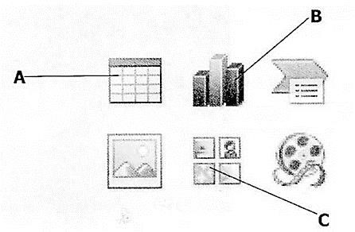

  - State the names of the frames marked by A and B

  - State the use of frame C

  - State one device apart from a computer that is required to run a presentation.

  - State one similarity between a Word Processor and a Desktop Publishing Package.

- AND, NOT and OR gates have been used in the following truth table. Complete the outputs indicated.

A | B | C | E = NOT C | F = A OR B | E AND F
1 | 0 | 1 | 0
1 | 1 | 0 | 1

- Two typical user interfaces are shown below.
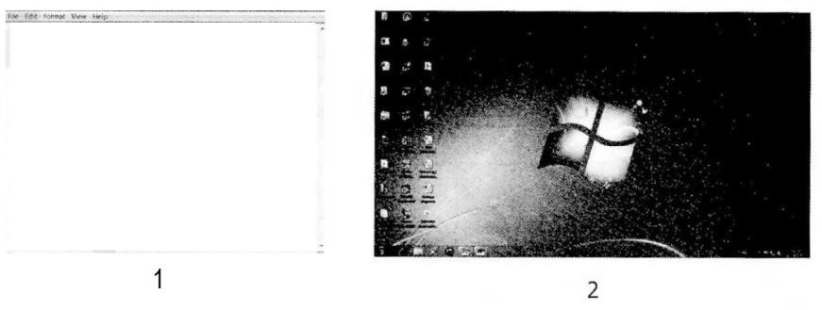
  - Explain the meaning of the term, user interface.

  - Mention the mouse function not applied in interface 1, but possible in interface 2.

  - State the application software that makes use of interface 1.

  - State the system software that uses interface 2.

- A modern meat storage cold room uses computer systems to control the freezing equipment. The cold room is equipped with sensors that monitor room conditions and feed data back to the micro processors.

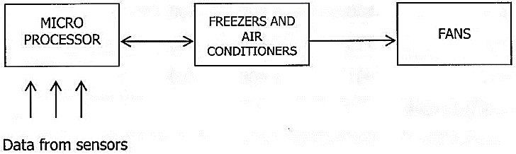

  - Give one example of data captured from sensors in the cold room.

  - When loading and offloading the meat stocks, the freezers go off while the air conditioners come on. Explain how the system is able to do this automatically.

  - Give one reason why data is fed back to the micro processors from sensors.

- Chinyemba runs a small business of sewing clothes. To keep a record of the cost of business, he uses a software package as shown below.

Material Wages Rent Tax Total
April 830 1 400 400
May 715 1 400 400
June 901 1 400 400
Total Expenses

  - What software package is suitable for this record?

  - Each month, Chinyemba types in the cost of various items. Explain why he does not need to type in the total cost.

  - When "Total Expenses" was typed, it could not appear fully. What could be done so that it is fully displayed?
  - Explain how the amounts can be changed to show ngwees, that is 830.00.

- Mwikisa runs a small trading business. He wants to change from a manual wages system to a computerised one.
  - Give one reason why it is important for him to undertake a feasibility study before considering the change to a new system.

  - Give one advantage to Mwikisa of buying a software package instead of writing the program for calculating wages.

  - Mention two types of tests he can carry out to check if the system works well.
Type 1 …………………………………………………………………………………………………………….. Type 2 …………………………………………………………………………………………………………….

- Most big organisations depend on large networks to run their businesses. One of their main concerns is data security.
  - Give a type of network on which security is critical.

  - Give one type of security threat common on networks.

  - Give one advantage of a bus topology.

- The following algorithm in pseudo code is used to calculate the area of a triangle, given base (b) and height (h).

START
Enter (b)
Enter (h)
IF (b < 0) or (h < 0) THEN
PRINT input error
ELSE
Calculate Area = ½*b*h
Print Area
END IF STOP

Rewrite the algorithm using a flow chart in the box on the right.

Section B

13 Read the following scenario carefully and use it to answer the questions that follow.

At Channa School, a charity has been formed for student donations and profits from school fundraising events. Each class competes to win the school charity shield for the most money collected in the year. The records for this are manually done.

When a student donation is recorded, the following details are always written in the class record book. • Student name
- Date
- Class
- Amount of donation
When a profit from a fundraising event is recorded, the following details are written in the class record book.
- Event name
- Date
- Class
- Profit made
Description of current system
- Paper based
- donations recorded by each claim
- all class records recorded in school donations master file

- A Systems Analyst will take up the project to computerise this system. Give two tools he could use to check the progress on this project.

- The analyst must study the existing recording system from the students who have used it. State one method that would not be suitable to study this system. Explain why the Systems Analyst should not choose that method.

Method: ……………………………………………………………………………………………………..

Explanation: ………………………………………………………………………………………………………

- In the choice of hardware to be used, the analyst has proposed that a laptop computer and smart phone be used to run the system.

  - Give one use of the laptop for this system.

  - Give one use of the smartphone for this system.

- State what you would use the following symbols for in the project.
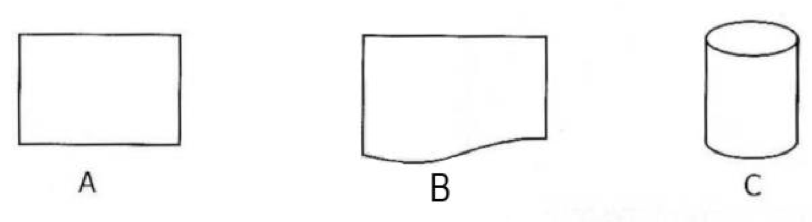
  - …………………………………………………………………………………………………………
  - …………………………………………………………………………………………………………
  - …………………………………………………………………………………………………………

- If the two sets of details are used to create databases, which two fields can be used to link the two databases?
Field name 1 …………………………………………………………………………………………….
Field name 2 …………………………………………………………………………………………….

- When the new system is finally in place, what effect would it have on the venture and the users of the system?
The Venture ……………………………………………………………………………………………. The Users …………………………………………………………………………………………….

- What type of maintenance would be appropriate for this system?

- Describe one future development note that can be included in this system.

Cen Nu |  | tre  mber |  | Candidate Number
Candidate Name_________________________________

EXAMINATION COUNCIL OF ZAMBIA

Examination for School Certificate of Ordinary Level


Computer Studies 7010/1

Paper 1

Friday 22 NOVEMBER 2019

Additional information:

Time 2 hours 30 minutes

Section A
- (a) Explain the meaning of the term byte.
………………………………………………………………………………………………………………… [2]
(b) Convert 4A (hexadecimal) to binary. Show your working.
…………………………………………………………………………………………………………………….[3]

- (a) Given one input and one output device that benefit people with special needs.
Input ……………………………………………………………………………….………………………… [1]
Output …………………………………………………………………….………………………………… [1]

(b) Explain the usage of the devices given in (a) with respect to input and out.
Input ……………………………………………………………………………………….…………………… [1]
Output ………………………………………………………………………………………………………… [1]

- (a) Explain the meaning of the term generic software.
……………………………………….....................................................................................[2]
(b) Give two examples of generic software.
      - ……………………………………………………………………………………..…………….. [1]
      - ……………………………………………………………………………………………………….. [1]

(c) Give one difference between generic software and custom software.
………………………………………………………….……………………………………………………………[2]

- (a) Name two types of operating systems.
      - ………………………………………………………………………………………….……………. [1]

      - ……………………………………………………………………….………………………………. [1]
(b) State two utilities found in the operating system.
      - …………………………………………………………..………………………………………………. [1]
      - ……………………………………………………………..……………………………………………. [1]

- Give two bad habits to avoid when using a computer.
    - ……………………………………………………………..………………………………………………………... [1]
    - …………………………………………………………………..…………………………………………………... [1]

- (a) Explain the meaning of the term hardware.
…………………………………………………………………………………………..…………………………………
…………………………………………………………………………………………………………………………[2]

    - Describe two physical threats to hardware.
Threat 1: …………………………………………………………….…………………………………………. ……………………………………………………………….………………………………….[1] Threat 2: ……………………………………………………………………………………………………….
……………………………………………….………………………………………………….[1]

    - Give two factors to consider when selecting software to run on a particular type of hardware.
Factor 1: ………………………………………………………………………………………………….[1]
Factor 2: ………………………………………………………………………………………………….[1]

- The diagram below shows a logic circuit.
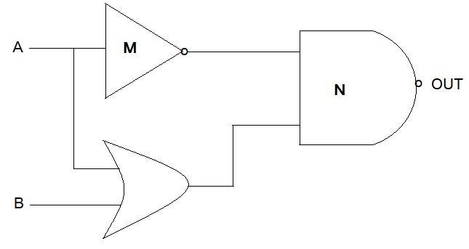
    - Identify the logic gates marked M and N.
M: ………………………………………………………..…………………………………………….. [1]
N: …………………………………………………………..………………………………………….. [1]

    - Give two examples of applications which use the logic circuits.
      - ……….…………………………………………………………………………………………………… [1]
      - ………… ………………………………………………………………………………………………. [1]

- The diagram below shows different components of an expert system.
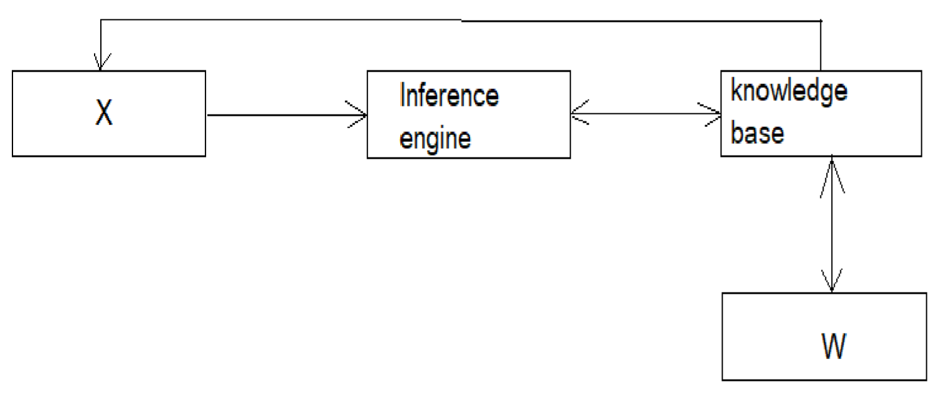
    - State the names of the components labelled W and X.
W: ……………………………………………………………………………………………………….. [1]
X: …………………………………………………………………….………………………………….. [1]

    - Name a component of the system which must be kept up to date.
………………………………………………………..…………………………………………………………………[1]
    - State one drawback of expert systems.
……………………………………………………….………………………………………………………………… [1]

- FM boutique keeps a stock list of jeans in a computer file. Part of the records are shown in the table below.

Item Code | Colour | Location | Quality
121 | B | L24 | 100
165 | W | C58 | 100
231 | W | L24 | 28

    - Name a field which qualifies as a primary key.
…………………………………………………………………………………………….…………………… [1]

    - State two reasons why the location field is coded.
      - ………………………………………………………………………………….……………………. [1]
      - ………………………………………………………………………………………………………. [1]

(d) State one validation check that would be made on the location code.
……………………………………………………………………………………….…………………………… [1]

- The diagram below shows a network.
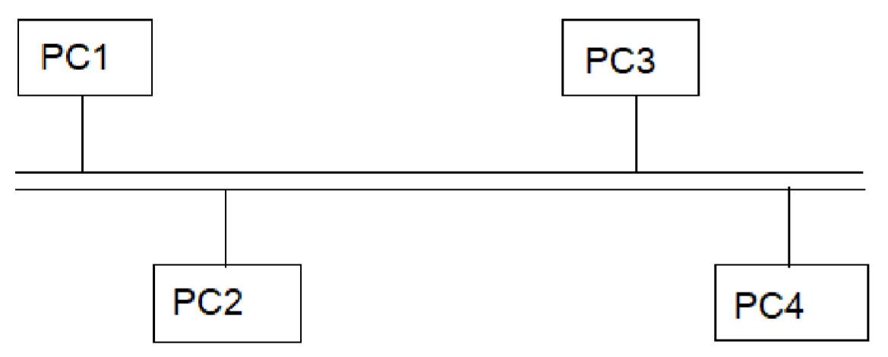
    - Identify the network typology shown above.
………………………………………………………………………………………………………………………… [1]

    - Give one advantage and one disadvantage of the typology above. [2]
Advantage: ……………………………………………………………………………………………………... [1]
Disadvantage: …………………………………………………….…………………………………………….[1]

- (a) State one health and one safety risk associated with the use of computers.
Health risk: ………………………………………………………..…………………………………………….. [1]
Safety risk: ……………………………………………………………………………………………………….. [1]

(b) Describe the protection measures for the risks stated in (a).
Health : …………………………………………………………………………………………………………….. [1]
Safety : …………………………………………………………………………………………………………….. [1]

- Study the algorithm below.
Begin
count = 0 sum = 0
WHILE count < 5 DO count = count + 1
sum = sum + count
ENDWHILE
Display sum
End

  - Dry-run the above algorithm and give the output.
…………………………………………………………………………………………………………………………………[2]
  - Rewrite the above algorithm using the REPEAT ……. UNTIL ….. Structure.
………………………………………………………………………………………………………………………………………
…………….……………………………………………………………………………………………………………………[5]

Section B
- Read the following scenario carefully and answer the questions that follow.
Description of existing system
Chicoolo School uses a paper based system to manage information of their learners.
Grade teachers keep information of their respective learners such as Name, Guardian, Address, Age, etc. in class Register, while the Guidance teacher keeps a record of academic performance of all the learners of Academic performance cards. All the records of the fees payment status of each pupil are kept by the accounts office.
Description of proposed computer based system
The proposed system will be developed with a view to keep information about the learners in one data pool.
The pupils, teachers and support staff would be expected to easily use the system through a friendly interface, quickly retrieve records, easily generate reports, quickly validate the records and process the data quickly.

- Identify two problems in the current system (manual system).

- Give two objectives of the new system to be developed from the description given.

- Give two project tools the systems analyst can use to monitor or track progress of project.

- State the difference between technical documentation and user documentation.

- The analyst suggested two methods of changeover, Parallel and Direct.
State two advantages and two disadvantages of the above suggested methods of changeover. Parallel changeover advantages
  - ………………………………………………….………………………………………………………….[1]
  - ………………………………………………………………………….………………………………….[1]

Drawbacks
  - ………………………………………………………………………………………………..……………….[1]
  - …………………………………..…………………………………………………………………………..[1]

Direct changeover advantages
  - …………………………………………………………………………………………….………………….[1]
  - ………………………………………………………………………………………………………………..[1]
Drawbacks
1 …………………………………………………………………………….………………………………….[1] 2 ………………………………………………….……………………………………………………………..[1]
- State two types of data that could be used during testing of the new system.
Cen Nu |  | tre  mber |  | Candidate Number
Candidate Name_________________________________

EXAMINATION COUNCIL OF ZAMBIA

Examination for School Certificate of Ordinary Level

Computer Studies 7010/1

Paper 1

Monday 22 NOVEMBER 2021

Additional information:

Time 2 hours 30 minutes

Section A [50 Marks]
Answer all questions in this section in the space provided

- Name three features of a Graphical User Interface (GUI).

- Below is a diagram showing part of the directory structure on a computer disk.
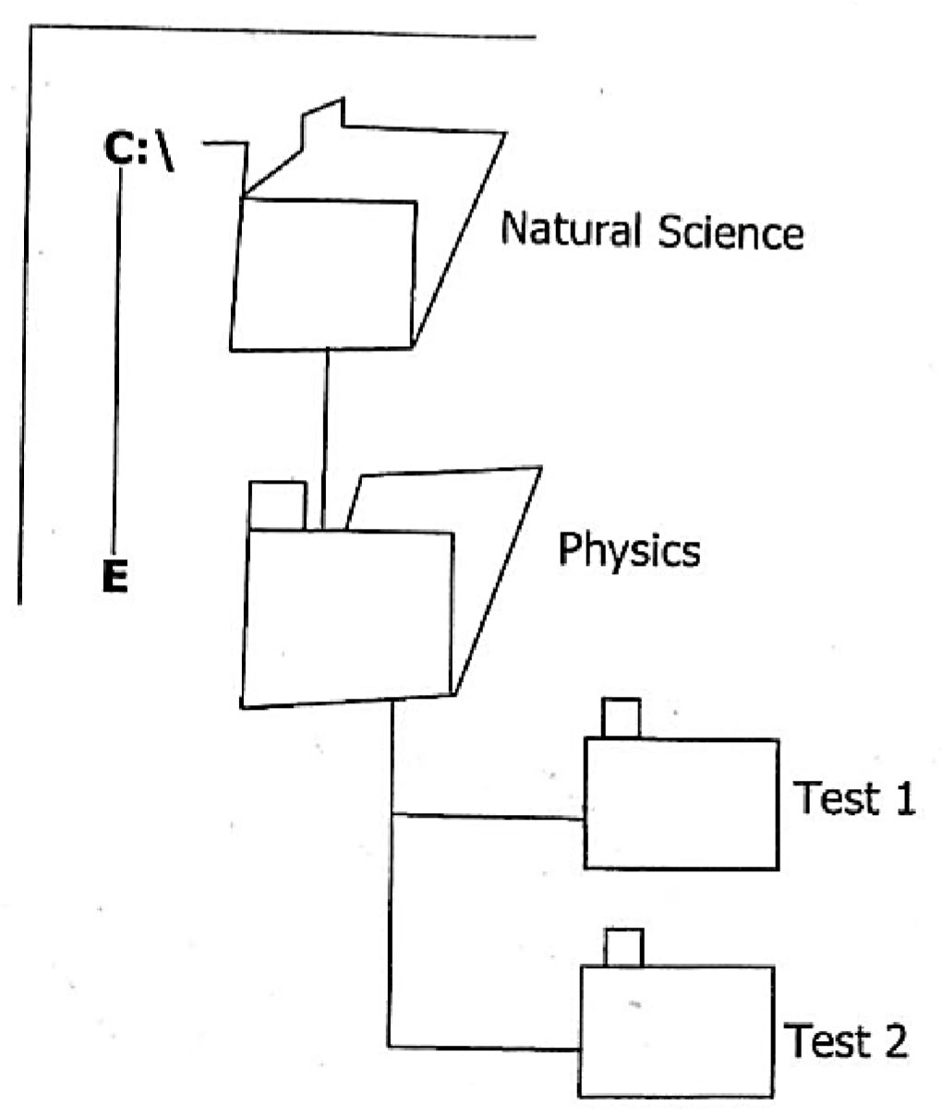
  - Name the root directory in the diagram above……………………………………………………….

  - When the Physics folder is deleted,

(i) which folder(s) will remain?.......................................

(ii) which folders (s) will be deleted? ……………………………….

  - Explain how a user can recover the deleted folder(s). ………………………………………………
………………………………………………………………………………………………………………………………..

- (a) State another name used to refer to a printed copy of a document.

  - Name a type of printer suitable for printing (i) receipts in a supermarket, (ii) letters in an office.

  - Give one characteristic of a printer suitable for use in a supermarket.

- (a) Convert the hexadecimal number 8E into denary (Show your working).

(b) Explain why data is coded.

- (a) Give one difference between record and a file.

  - State two types of data that could be used in a database programme.

  - State the name given to key fields used to link two tables together.

- Smart phones, tablets and other mobile devices that have access to the Internet can be used in Computer Based Learning (CBL) by learners.

  - State two ways a lesson can be given using Computer Based Learning

  - Give one disadvantage of using CBL.

  - State one drawback of social network platforms among learners.

- (a) Name one multimedia software.

(b) Give the term used to describe the copying of software which is licenced.

- (a) Explain the meaning of the term 'phishing'.

  - Give one use of cookies installed on a user's computer.

  - State a term that describes unsolicited e-mails. (d) Give one way in which data can be destroyed.

- The diagram shows a logic network with three inputs A, B and C. The first outputs are S and T, finally X.
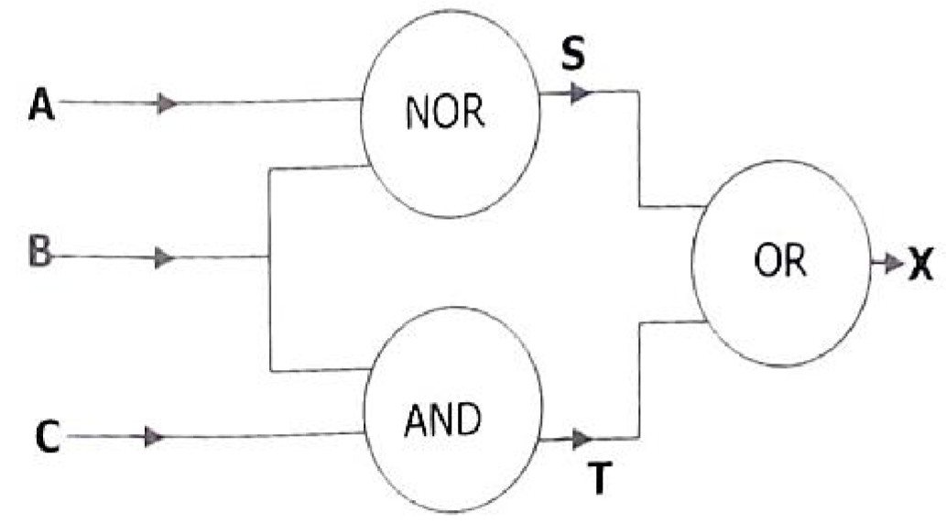

Using the information provided and the logic circuit above, complete the following truth table below.

A | B | C | S | T | X
1 | 1 | 1 | 0 | 1 | 1
1 | 1 | 0 | 0 | 0
1 | 0 | 1 | 0 | 0
1 | 0 | 0 | 0 |  | 0
0 | 1 | 1 | 1 |  | 1
0 | 1 | 0 | 0 | 0 | 0
0 | 0 | 1 |  | 0
0 | 0 | 0 |  | 0

- (a) Give two uses of the Internet.

(b) A Uniform Resources Locator (URL) is shown below. Identify the three parts labelled A, B and C.
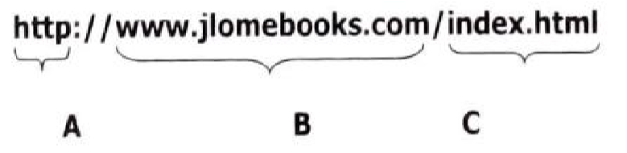
PART A …………………………………………………………………………………… PART B ……………………………………………………………………………………
PART C ……………………………………………………………………………………

- A school tuckshop uses a spreadsheet to calculate the cost of items they sell. Part of the record of items is shown in the following spreadsheet.
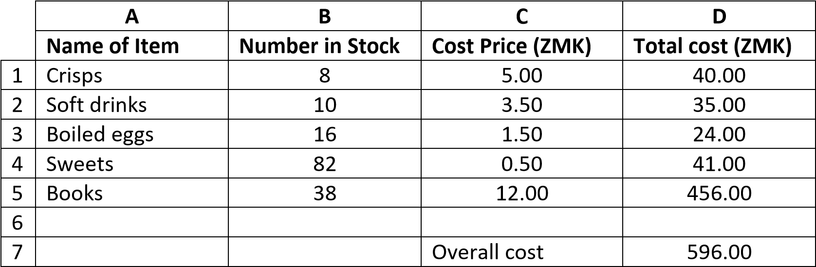
  - State the number of the rows shown in the spreadsheet.

  - Give the cell reference of the cell that contains 3.50.

  - Explain why financial models could be useful for the tuckshop to predict the profit for the future.

- The system flowchart shows the stages in the production of test result slips.
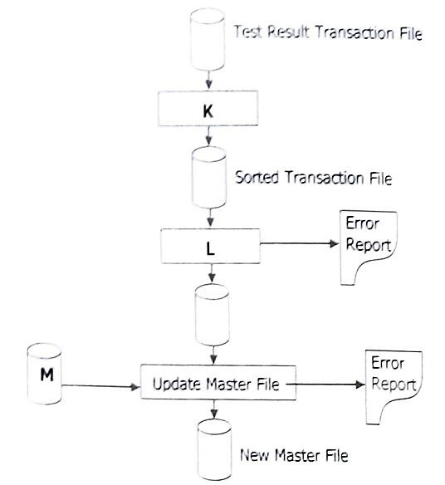
  - Identify file M.

  - State the processes K and L.
M …………………………………………………………………………..
L …………………………………………………………………………..

  - Give one reason why validation is an important part of this update process.

SECTION B [20 Marks]
There are three questions in this section. Answer two Questions only. Question one is compulsory. Choose one from the remaining two questions.

- Read the following scenario carefully and answer the questions that follow. Blow Library uses a paper based record system for sending books.

Description of the existing system

When a client enters the Library, the Librarian records the following:
  - Client Name
  - Date Borrowed
  - Date of Return
  - Book Category
  - Book Title
  - Book Serial Number

Description of the proposed computer-based system.
The analyst will need to ensure that a plan is made to design, test and implement the new computerised system.
The new system will use barcodes on books to identify its name and automatically display the serial number of a book and when it is supposed to be returned.

  - Give one problem associated with the current system

  - Complete the following table by filing in the appropriate stages using the tasks provided. The first one has been done for you.

Task | Stage
Observe the current system in operation | Analysis
Software and hardware installation
Prepare data capture and validation methods
Decide whether or not to continue with the project

  - Give a reason why the library would prefer to get a tailor made software rather than already made software.
  - State three types of test data that can be used to test the programme.

  - State one item found in user documentation.

  - Explain the importance of corrective maintenance carried out on a new system.
[10 marks]

- A School wants to create a website using html that will contain hyperlinks.
  - State two types of hyperlinks that could be used in linking the web pages.

  - Write a code that can be used to connect the current page to a new page called ‘’contact us’’.

  - The name of the heading of the webpage is "My School." Write an html tag to display the heading in red colour.

  - Use the subjects given below to write the ordered list tag.
    - Mathematics
    - Science
    - English
    - Computer Studies
[10 marks]

- (a) Name two Keyword statements in SQL.

(b) The table shows part of a computer database of employee records.

Employee No. | Name | Age | Salary
M 1006 | Zulu. M | 35 | 8 000.00
M 1025 | Moono. A | 32 | 6 500.00
M 1104 | Twipa. C | 40 | 10 000.00
M 1037 | Kavombo. T | 39 | 6 000.00
M 1124 | Wasilota. S | 42 | 7 000.00

    - State the data types used to create the name and salary fields.
Name field
Salary field

    - Write the SQL statement that would sort the records in ascending order of name and salary.

Cen Nu |  | tre  mber |  | Candidate Number
    - Write the SQL statement to remove the record with employee number M1104 from employment table.
[10 marks]

Candidate Name_________________________________

EXAMINATION COUNCIL OF ZAMBIA

Examination for General Certificate of Education Ordinary Level

Computer Studies 7010/1

Paper 1

Friday 29 JULY 2022

Additional information:

Time 2 hours 30 minutes

Section A (50 Marks]
Answer all questions in this section in the spaces provided.

- (a) Explain the meaning of the term input device'.

  - Give one example of software and hardware that assist blind person to use a computer system.

- Complete the table by filing in the missing information.
S/N | Job title | Duties
1 |  | Designs and develops websites
2 | Computer Technician
3 | Database Administrator
4 |  | Offers support to staff when problems arise as they are technical support

- (a) State one method that can be sed to capture data.

  - Name the Validation check that ensures that data captured falls within specified limits

  - Explain why data is entered twice into a computer system during data collection.

- (a) Name the logic gate represented by the switches below.
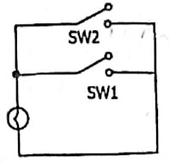

  - (i) Draw a logic gate which has the following truth table.
Logic gate diagram
Input |  | Output
A | B | C
0 | 0 | 1
0 | 1 | 1
1 | 0 | 1
1 | 1 | 0

    - Convert the output 1110 in column C of the truth table to decimal.

- Pensulo uses Electronic Fund Transfer Point of Sale (EFTPOS) each time he buys items in a supermarket

(a) Give one advantage of using EFTPOS to
    - Pensulo

    - the supermarket.

  - Explain how the EFTPOS system negatively affects society.

- The following diagram shows a computer network.
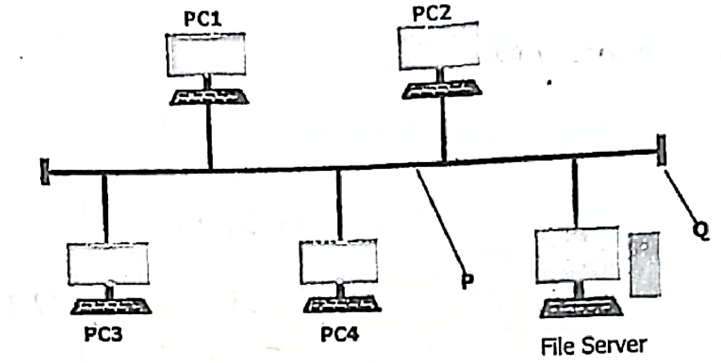
  - Identify the component marked P.

  - State the purpose of
    - Q

    - File Server.

(c) Name the device needed to connect the above network to the Internet.

- (a) Give two benefits of using licensed software.

  - Describe two natural disasters that could cause damage to backups.

- The following table shows a spreadsheet used to keep details of cars sold in one week.
 | A | B | C | D | E | F
1 | Car | Opening stock | Number  sold | Cost (ZMK) | SALE (ZMK) | COMMENT
2 | AUDI | 15 | 9 | 135 000
3 | BMW | 18 | 12 | 85 000
4 | FORD | 10 | 4 | 350 000
5 | VOLVO | 5 | 5 | 210 000

  - Write a formula to be entered in cell E2 to calculate the sale of AUDI.

  - Write formula to be entered in Cell F2 that will display a comment based on the criteria given below:

Opening Stock 10 display "Re-order’’ AND

Opening Stock >10 display "Stock level Ok’’

………………………………………………………………………………………………………………………………

………………………………………………………………………………………………………………………………

  - (i) Name a cell containing

Data; …………………………………………………………………………………………………………

    - Information. ……………………………………………………………………………………………..

- (a) Dry run the flowchart below when N = 50.
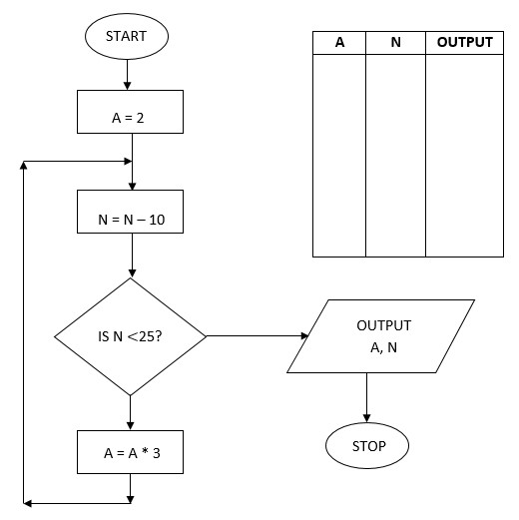

  - Name the pseudocode loop structure which is the same as the loop in the flowchart.

- A new mining town is concerned with Increased water pollution. A data logging system has been set up to detect the pollution levels in the area.
  - Explain the meaning of the term 'data logging'.

  - Give one advantage of using a data logging system for monitoring water pollution in the mining town.

  - Stale one format in which data is displayed on the computer after being processed by the system.

- (a) List two elements of multimedia.

  - Apart from the computer, give one suitable hardware device that can be used in a multimedia presentation.
  - Give one benefit to the learners of presenting a lesson using multimedia. [1]

- Calculate the check digit of 5104322017 using the following Instructions:
Step 1: | Add the digits in the odd positions and multiply the sum by 3.
Step 2: | Add the digits in the even positions.
Step 3: | Add the two results you obtained in Steps 1 and 2.
Step 4: | Find the next multiple of 10 to the number obtained In Step 3.
Step 5: | To find the check digits, calculate the difference between the number
obtained in step 4 and step 3.

Section B [20 Marks]
There are three (3) questions in this Section. Question one (1) is Compulsory. Choose other two questions.
- Read the following scenario and answer the questions that follow.
A school management wishes to change from a manual records system to a computer based system.
Description of the Manual System
  - Learners fill in forms by completing personal details.
  - Learners complete the accounts details form.
  - Personal details are kept in the Guidance Teacher's office.
  - Accounts records are kept in the Account's office.

  - State one computer and one business related objective for the proposed system.

  - Give two change-over methods that can be used to Implement the new system and in each method, state Its advantage.

  - Give two benefits of keeping learners' records in separate offices as stated in the description.

  - Give two examples of test strategies that can be performed on the new system.
[Total: 10 marks]

- (a) Debug the three lines with errors in the following C++ code.
Line 1: #include <1Ostream.h>
Line 2: Int main
Line 3: {
Line 4: a, b int;
Line 5: Cout << "Enter the first number"
Line 6: Cin >>a;
Line 7: Cout <<"Enter the Second number:"
Line 8: Cin >>b;
Line 9: C= >>a + b;
Line 10 Cout << "C= ",C;
Line 11: return 0;
Line 12:}
- State two rules for declaring variables in C++.

- Write two C++ reserved words.

- State the meaning of the following C++ items:
{ ………………………………………………………………………………………………………………… Cout ………………………………………………………………………………………………………………….

- Name the programme that reads and executes C++ programmes.
[Total: 10 marks]

3 Study the student table and answer the questions that follow.
STNO | Name | Class | Subject
1001 | Hamududu B | 12E | Computer
1002 | Simbeye J | 10A | Mathematics
1003 | Njomke M | 11D | Physics
1020 | Tebulo E | 11D | Computer

- Write an SQL Command to

  - display the entire table

  - view results in ascending order of STNO,

  - insert the record
1010, "Bwalya T", 12B, "Additional Mathematics".

- Name a field that can be used as a primary key in the student table.

- State the data type for the field class

- Name the process of searching for a record in a database.

- Write down the number of fields in the student table,

[Total: 10 marks]

Cen Nu |  | tre  mber |  | Candidate Number
Candidate Name_________________________________

EXAMINATION COUNCIL OF ZAMBIA

Examination for School Certificate of Ordinary Level

Computer Studies 7010/1

Paper 1

Thursday 17 NOVEMBER 2022

Additional information:

Time 2 hours 40 minutes Marks: 70

SECTION A: [50 MARKS]
Answer all questions in this section in the spaces provided.

- (a) Name one device that produces hardcopy documents.

  - Give one similarity and one difference between RAM and ROM.

  - Explain the importance of regularly updating an antivirus installed on
[Total: 5 marks]

- An engineer uses the following code in his programme.
      - means off
      - means on
The code off on off off appears on the screen.

  - Write the code in binary form.

  - Convert 1010₂ to Octal.

  - Give one reason why data is converted to binary in a computer.
[Total: 4 marks] 3 (a) Explain the meaning of the term 'Deskilling'.

  - Give one benefit of introducing robots in an organisation.

  - Describe a way of training a robot to do new tasks. [Total: 5 marks] 4 (a) Give one example of personal data that can be classified as:
    - Public
    - Private

  - State one law found in the Data Protection Act.

  - Write one effect of exposing personal data to the public.
[Total: 4 marks]

- The figure below shows how files are organised on a computer using a hierarchical file system.
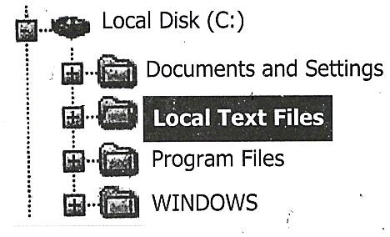

  - Name the
(i) Root directory, (ii) Sub-directory.

  - Apart from file management, state two other tasks performed by an operating system.

- Intranets and extranets are preferred networks in some organisations than the Internet.

  - State one difference between intranets and extranets.

  - Describe how a company can ensure safety of its information when using an extranet.
[Total: 4 marks]

- Read the following instructions used to command a robot to move.
    - Forward 30
    - Left 120
    - Forward 30
    - Left 120
    - Forward 30
    - Left 120
Write a shortened set of instructions using the REPEAT statement

- Computers are increasingly being used to monitor air pollution.
  - Name one sensor that is used to detect pollution in the air.

  - Mention a device that is used to convert data from the sensor to a microprocessor.

  - Give one difference between a monitoring and a control system.

- (a) Explain the meaning of the term Biometric System'.

  - Give one example of a Biometric System.

  - Give one advantage of a Biometric System has over a card system.

- The following database is used to keep a record of performances at a local theatre.
 |  | Performances
Show Number | Type | Title | Date | Sold out
SN091 | Comedy | An Evening at Time | 01 Sept | Yes
SN102 | Drama | Old Places | 02 Oct | No
SN113 | Jazz | Acoustic Evening | 03 Nov | No
SN124 | Classical | Black Flavourites | 04 Dec | Yes

  - State the number of fields in the database.
  - Describe one validation check that could be carried out on 'Show Number’.
  - Show how the query below can be written on the query grid that follows. SELECT * FROM performance WHERE soldout "Yes" ORDER BY date

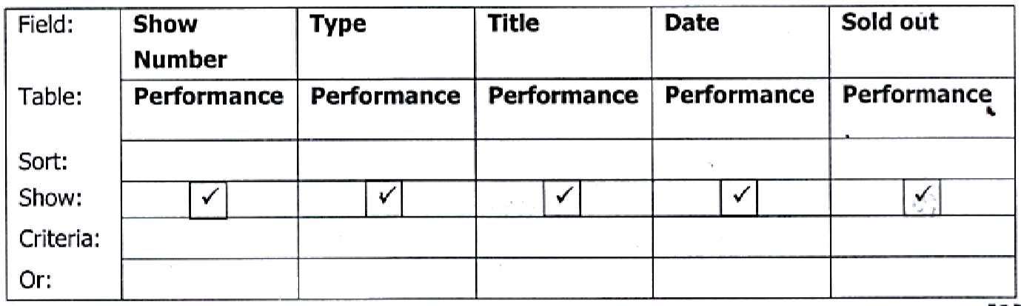
- (a) Complete the trace table for the following algorithm given that the number 4 is the Input value for x.

INPUT x
FOR m = 1 to x DO
        - = x – m
        - = 5 * y – m
END DO
OUTPUT z
x | m | y | z
4
4
4
4

(b) Name one other loop structure that can be used in (a) apart from the FOR loop.

- (a) Explain the meaning of the term 'digital crime'.

  - Give one effect of digital crime on mobile money.

  - State one measure that can be put in place to prevent digital crime.

SECTION B: [20 MARKS]
There are three (3) questions in this section. Answer two questions only. Question one (1) is Compulsory. Choose one from the other two questions.

- A systems analyst has been engaged to develop a computer based system for a company that uses a manual system for all business transactions.
  - Name two utilities the systems analyst can use to make an action plan.

  - Give two fact-finding methods that the systems analyst could use to gather information from the existing manual system and in each case, give a, reason for your answer.

  - Give three reasons why software requirements must be specified before the installation of a new system.

  - Give one reason why parallel changeover must be recommended for the new system.

- Study the Pascal program below and answer the questions that follow.
  - PROGRAM Maths;
  - VAR
  - n1, n2, Sum : Integer;
  - name : String;
  - BEGIN
  - n1 : = 5:
  - n2 : = 5;
  - sum: = n1+ n2;
  - name: = "Sepo";
  - Written ("Sum of n1 and n2 is ", Sum);
  - Written ("Average of n1 and n2 is", Sum/2);
  - Written ("My name is", name);
  - END

  - State the difference between Integer and String.

  - Write the screen display for lines 11, 12 and 13.

  - Write the change in the code to enable n1 and n2 be assigned a decimal number.

  - Give two reasons why Pascal is said to be a structured programming language.

  - Name a reserved word that ends with a full stop (.) in Pascal.

Name | ID
- (a) Write the HTML Code required to display the following:
(i)

(ii) Colour
    - Red
    - Blue

- Give two examples of empty tags.

- State the purpose of CSS in web design.
[Total: 10 marks]

Cen Nu |  | tre  mber |  | Candidate Number
Candidate Name_________________________________

EXAMINATION COUNCIL OF ZAMBIA

Examination for General Certificate of Education Ordinary Level

Computer Studies 7010/1

Paper 1

Friday 28 JULY 2023

Additional information:

Time 2 hours 40 minutes Marks: 70
SECTION A: [50 MARKS]
Answer all questions in this section in the spaces provided.
1 (a) Give one example of external memory.
……………………………………………………………………………………………………………………… [1]

- Name one output device other than a printer, monitor or touch screen.
……………………………………………………………………………………………………………………… [1]

- Explain why a touch screen is mostly used in self-service computer based systems.
……………………………………………………………………………………………………………………… [2]
[Total: 4 marks] 2 State three features of an operating system.
- ……………………………………………………………………………………………………………………… [1]
- ……………………………………………………………………………………………………………………… [1]
- ……………………………………………………………………………………………………………………… [1]
[Total: 3 marks]
- Convert the hexadecimal number FA7 into
  - Binary, [2]

  - Octal. [2]
[Total: 4 marks]

- At Londoleni Secondary School, the Computer laboratory was damaged by fire.
  - State two ways data and information could have been prevented from being lost completely.
    - …………………………………………………………………………………………………………… [1]
    - …………………………………………………………………………………………………………… [1]

  - Explain how the lost data could be recovered.
……………………………………………………………………………………………………………………… [1]
[Total: 3 marks] 5 Many people are now using credit and debit cards to make payments.
  - Give one advantage of this method of payment to the user
……………………………………………………………………………………………………………………… [1]

  - Give one security feature of a debit or credit card.
……………………………………………………………………………………………………………………… [1]
  - State the validation checks that are performed
    - when the card is inserted into the ATM machine;
…………………………………………………………………………………………………………… [1]
    - after the PIN has been entered.
…….……………………………………………………………………………………………………… [1]
[Total: 4 marks] 6 Computer systems have been introduced in many office environments of organisations.
(a) State two ways in which this new technology has affected employees.
    - …………………………………………………………………………………………………………… [1]
    - …………………………………………………………………………………………………………… [1]

(b) Describe two health risks associated with the increased use of computers.
    - …………………………………………………………………………………………………………… [1]
    - …………………………………………………………………………………………………………… [1]
[Total: 4 marks] 7 (a) Draw and label a star topology network which has a server and a printer.

(b) Explain the difference between intranet and extranet. [5]
Intranet: ……………………………………………………………………………………………………………
Extranet: ………………………………………………………………………………………………………. [2]
[Total: 5 marks]

8 The spreadsheet below shows part of the data of a computer accessories sales invoice.
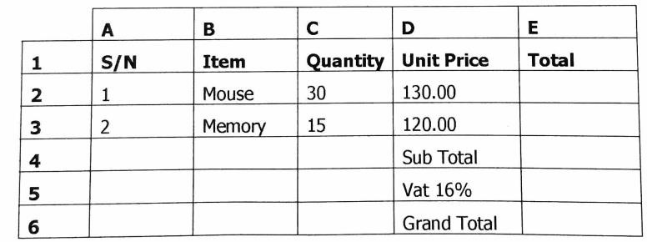

- State the formula that should be inserted in E2 to calculate the total cost of mice.
……………………………………………………………………………………………………………………… [2]
- Name three cells where contents would change if the entry in C3 was changed.
……………………………………………………………………………………………………………………… [2]
[Total: 5 marks] 9 (a) Explain the meaning of the term 'Computer Aided Design' (CAD).
……………………………………………………………………………………………………………………… [2]

(b) State two areas where CAD is used.
  - …………………………………………………………………………………………………………… [1]
  - …………………………………………………………………………………………………………… [1]

- Give one feature of a CAD system which makes it desirable in automobile designing.
……………………………………………………………………………………………………………………… [2]
[Total: 4 marks]

10 A toy turtle can be programmed to make movements on a floor using the instructions in the table below.
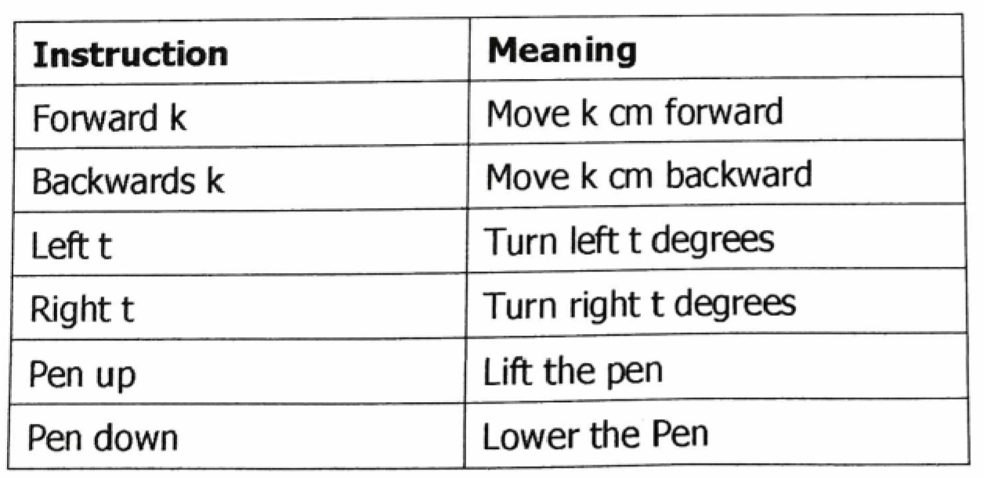

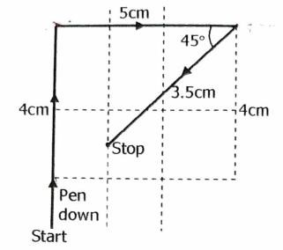
Complete the set of instructions to draw the path of the toy turtle shown by arrows.
Pen down
Forward 4cm
………………………………………………………………………………………………………………………
………………………………………………………………………………………………………………………
………………………………………………………………………………………………………………………
……………………………………………………………………………………………………………………… [4]
Stop
Pen up
[Total: 4 marks]

- Instead of 8 bits, a machine with a digital display screen uses a 7-bit display as output.
Data is coded 0 for off and 1 for on. For example
Digits a b c d e f g
1 1 1 1 0 1 1
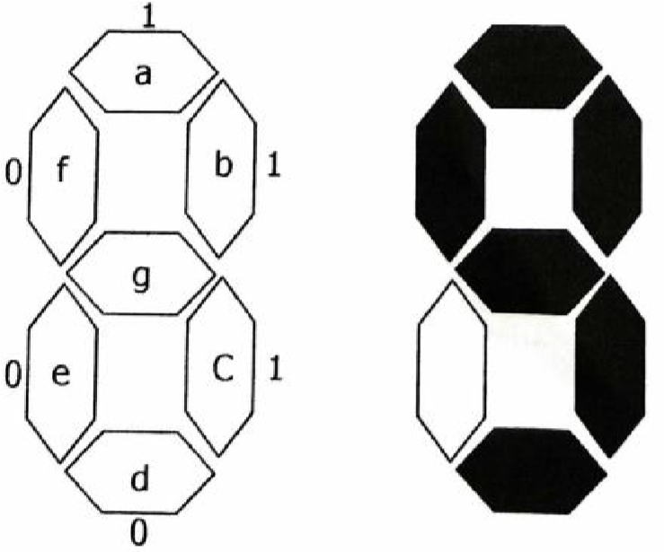

  - What is the 7-bit binary code for the digit displayed?
……………………………………………………………………………………………………………………… [1]

  - What character is displayed with the bit pattern 1110000?
……………………………………………………………………………………………………………………… [1]

  - Give one reason why all the letters of the alphabet cannot be shown on the display
……………………………………………………………………………………………………………………… [1]
[Total: 3 marks]

- Study the algorithm below and use it to answer the question that follows.

Start
Sum = 0
Get a value
Sum = Sum + value
Output the Sum
Go step 3 to get next value
Stop

Draw a flowchart from the statement in the algorithm.

[Total: 7 marks]
SECTION B: [20 MARKS]
There are three questions in this section. Answer two questions only. Question one is compulsory. Choose one from the other two questions.

- A Systems Analyst has been hired to develop a new computer-based system.
  - State the stage at which the Analyst would:
    - carry out a cost-benefit analysis;
…………………………………………………………………………………………………………… [1]
    - check what happens when two new records with the same name are created.
…………………………………………………………………………………………………………… [1]

  - The following table shows different change-over methods carried out during implementation stage in different situations. Complete the table by filling in the missing information. The first one has been done for you as an example.
Situation | Change-over method | Reason
Point of Sale (POS) for a supermarket | Phased | Low Cost of implementation
Medical System
Newly completed video library
[4]

  - The chart below shows the duration taken by each task during the project development phase of the new computer-based system. Use it to answer the questions that follow.
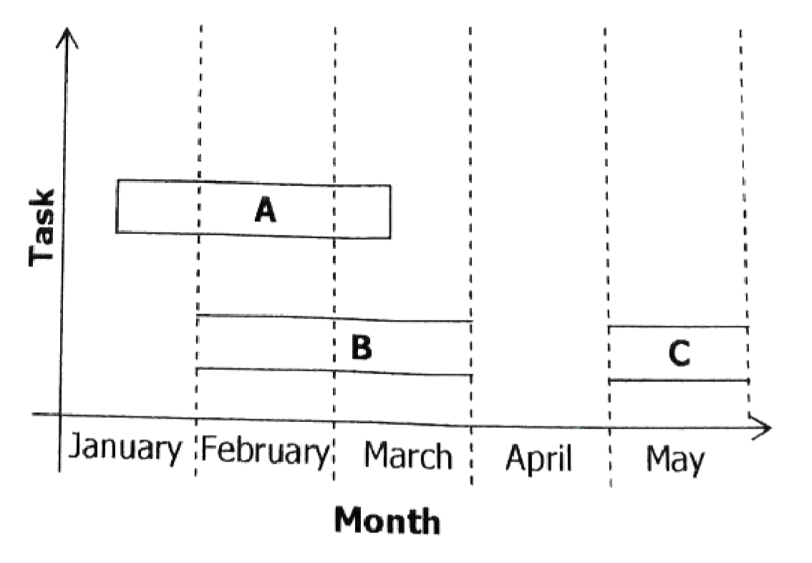

    - ldentify the project management tool shown on the chart.
…………………………………………………………………………………………………………… [1]

    - State two tasks that are running simultaneously.
      - ………………………………………………………………………………………………… [1]
      - ………………………………………………………………………………………………… [1]

    - Name the task that cannot start until another one has been completed.
…………………………………………………………………………………………………………… [1]
[Total: 10 marks]

- The following table shows part of a database which contains information about marks obtained by students in a test. Use it to answer the questions that follow.

STUDENT | FULL NAME | SUBJECT | MARK
ST1420 | Mary Silumesi | Maths | 90
ST1400 | James Hacintas | Science | 75
ST1442 | Kapalu Kayambo | English | 86
ST1405 | Muzi Lekani | Maths | 75
ST1488 | Namunola Norah | Science | 68

  - Write an SQL statement that was used to create the student table in the database.
………………………………………………………………………………………………………………………
………………………………………………………………………………………………………………………
………………………………………………………………………………………………………………………
……………………………………………………………………………………………………………………… [4]

  - Write a query statement to display names and subjects of students who have marks above 75.
………………………………………………………………………………………………………………………
………………………………………………………………………………………………………………………
……………………………………………………………………………………………………………………… [3]

  - Write an SQL statement that inserts the following record of a student in the student table.
ST1410 Juliet Bwalya English 95.
………………………………………………………………………………………………………………………
………………………………………………………………………………………………………………………
………………………………………………………………………………………………………………………
……………………………………………………………………………………………………………………… [3]
[Total: 10 marks]

- Study the program code below and use it to answer questions that follow.
  - Program multiplication table;
  - var
  - Integer: number, count, answer;
  - Begin
  - Printin ("Enter a number");
  - Read (number);
  - For count= 1 to 4 do
  - begin
  - answer = number *count;
  - Printin (answer);
  - readin; 13 End.

  - Name two variables in the program.
1 …………………………………………………………………………………………………………… [1] 2 …………………………………………………………………………………………………………… [1]

  - List the results obtained when line 5 is executed.
……………………………………………………………………………………………………………………… [1]

  - (i) List the number of times line 11 would run.
…………………………………………………………………………………………………………… [1]

(ii) List the number of times line 12 would run.
…………………………………………………………………………………………………………… [1]

  - What are the outputs when the program is run?
……………………………………………………………………………………………………………………… [4]

  - Name one reserved word in Pascal apart from those used in the program,
……………………………………………………………………………………………………………………… [1]
[Total: 10 marks]

Cen Nu |  | tre  mber |  | Candidate Number
Candidate Name_________________________________

EXAMINATION COUNCIL OF ZAMBIA

Examination for School Certificate Ordinary Level

Computer Studies 7010/1

Paper 1

Thursday 16 NOVEMBER 2023

Additional information:

Time 2 hours 40 minutes Marks: 70
SECTION A: [50 MARKS]
Answer all questions in this section in the spaces provided.
- (a) Give one difference between data and information.
Data ……………………………………………………………………………………………………… [1]
Information ………………………………………………………………………………………….. [1]
  - Name a device that can be used to capture analogue data at a point-of-sale in a supermarket. [1]
  - State the smallest data size that can be stored in a computer system. [1]
[Total: 4 marks]

- (a) Give the use of a data bus and an address bus in a computer system.
    - Data bus [1]
    - Address bus [1]
  - State the purpose of a program counter in data processing. [1]
[Total: 3 marks]

- (a) Give two advantages of using a tailor-made software to a company. [2]
  - (i) Give one example of open-source software. [1]
(ii) State one advantage of using open-source software. [1]
[Total: 4 marks]

- The following diagram shows a logic circuit used to operate an electronic device.
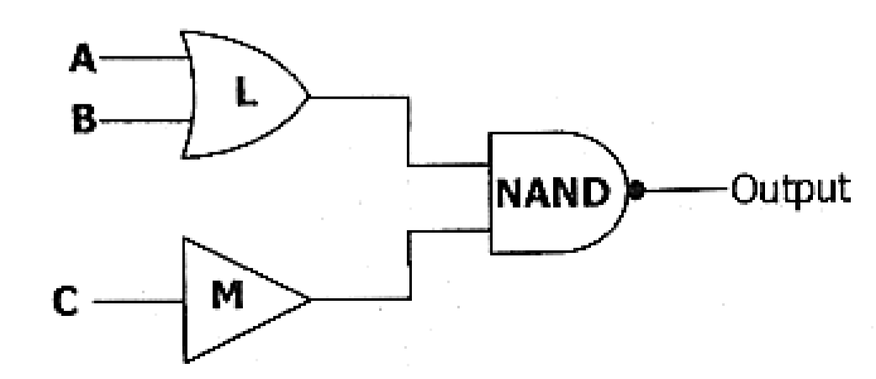
(a) (i) Identify the logic gate L. [1]
(ii) State the purpose of logic gate M in the circuit. [1]

  - Complete the truth table for the NAND gate.
A B OUTPUT
0 | 0
0 | 1
1 | 0
1 | 1
[4]
- (a) Give one benefit of converting hardcopy books to electronic books (e-books). [1]
  - Name one hardware used to convert hardcopy books to electronic books for an e-library. [1]
  - State one other role of a librarian in e-library apart from converting hardcopy books to e-books. [1]
  - Give one disadvantage of e-library to users. [1]
[Total: 4 marks]

- (a) Complete the following table by filling in the missing information.
Position |  | Responsibility
Network Administrator |  | [1]
 | [1] | Monitors and tracks criminal activities such as fraud and hacking.

  - Explain why most companies do not allow their employees to connect their
personal computing devices to the company network. [1]

- The following spreadsheet shows the salary scales and contract hours of seven workers.
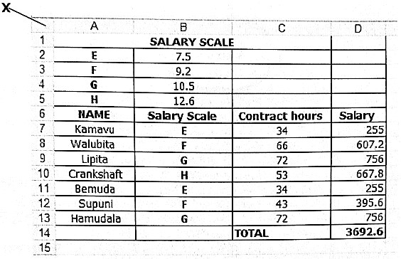

(a) State the use of the feature labelled X. [1] (b) State the adjustment applied to cells A1, B1 and C1. [1]
(c) Write the function that was entered in cell D8 to calculate the salary for Walubita.
[Total: 4 marks]

- The following diagram illustrates how information is transferred from one computer to another on the Internet.
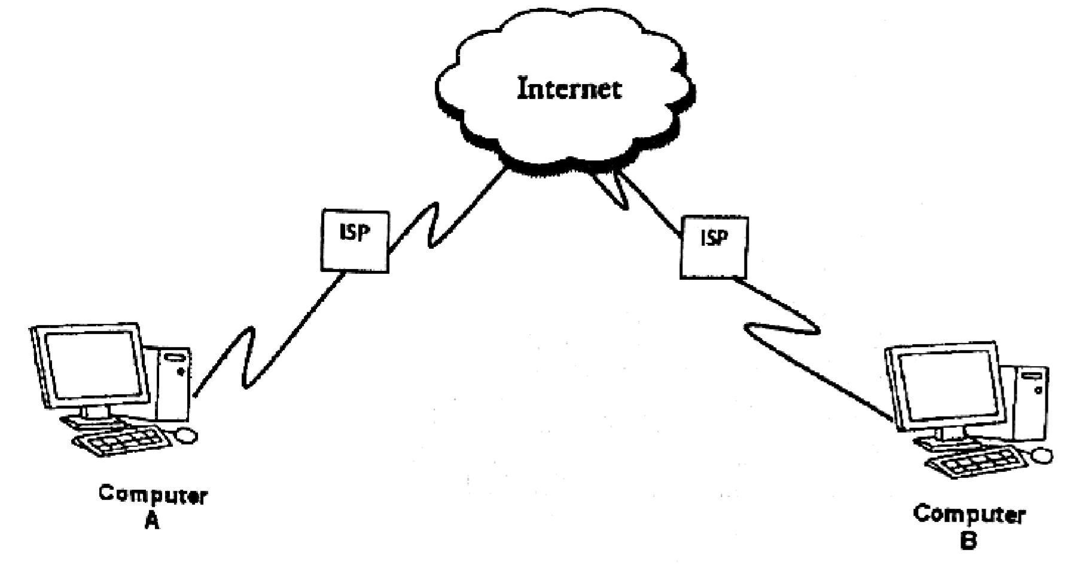
  - Name the hardware on Computer A which enables it to connect to the Internet
Service Provider (ISP). [1]

  - State one other service provided by the ISP to users apart from connections to the Internet. [1]

  - Name the method used to protect information being transferred from Computer
A to Computer B. [1]

(d) State the feature on the Internet that enables computers to locate resources. [1]
[Total: 4 marks]

- (a) State two data types in Python. [2]

  - Explain the meaning of the term 'debugging'. [2]
[Total: 4 marks]

- At a commercial farm, robots can perform a variety of tasks such as planting, weeding, spraying and picking of crops.

  - Give one sensor that is used in the robot when performing tasks at the farm. [1]

  - State one disadvantage of using robots in agriculture. [1]

  - Give one activity that can be programmed in the robot using turtle instructions. [1]

  - Explain how a recently programmed robot can be 'trained' to perform a new task at the farm. [2]
[Total: 5 marks]

- (a) Give one skill required in performing the following tasks:
    - Project Planning: [1]
    - Project Monitoring: [1]

  - Name two types of schedules used to monitor the progress of a project. [2]
[Total: 4 marks]
- The following flowchart shows the process of testing and treatment of Covid-19 patients.
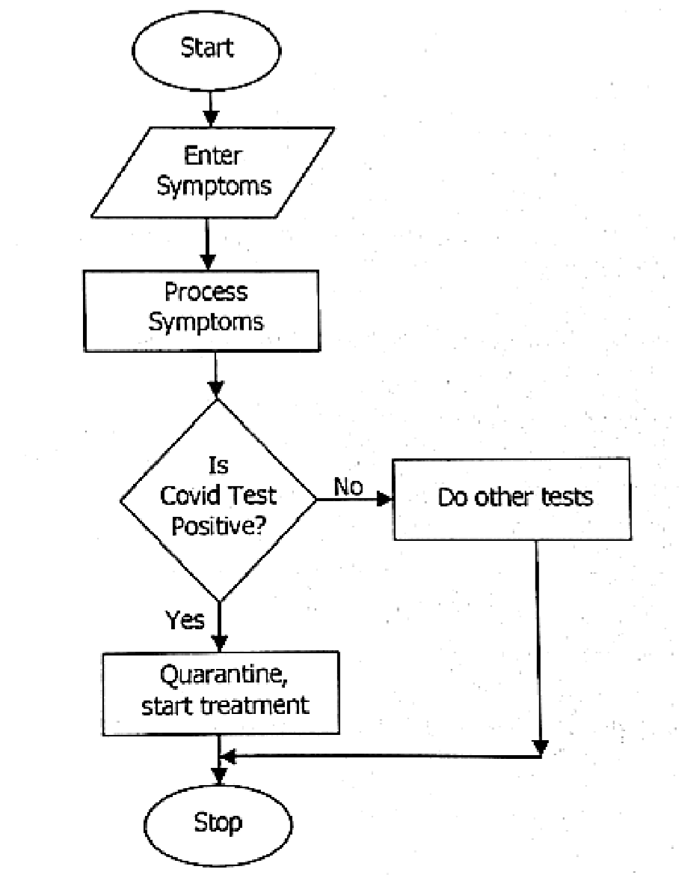
Convert the flowchart to Psuedocode.

SECTION B: [20 MARKS]
There are three (3) questions in this section. Answer two questions only. Question one (1) is Compulsory. Choose one from the other two questions.

- A systems analyst has been engaged to review a manual stock control system of a shop and develop a new computerised system which must be implemented if accepted by management.

  - Give one computer objective and one business objective of the new stock control system.
Computer objective:
Business objective:

  - State two sources of information for the analyst to study the current system.
Source 1
Source 2
  - Apart from acceptance, give one other reason why the analyst must present to management the findings from the study of the current manual system.

  - Name two activities that would be carried out during the feasibility study.

  - Explain why the FAQs (Frequently Asked Questions) are included in the user documentation.

  - Mention the type of maintenance where the system is modified to meet new demands by the user.

- The following database shows records of employee allowances that were paid in one month.
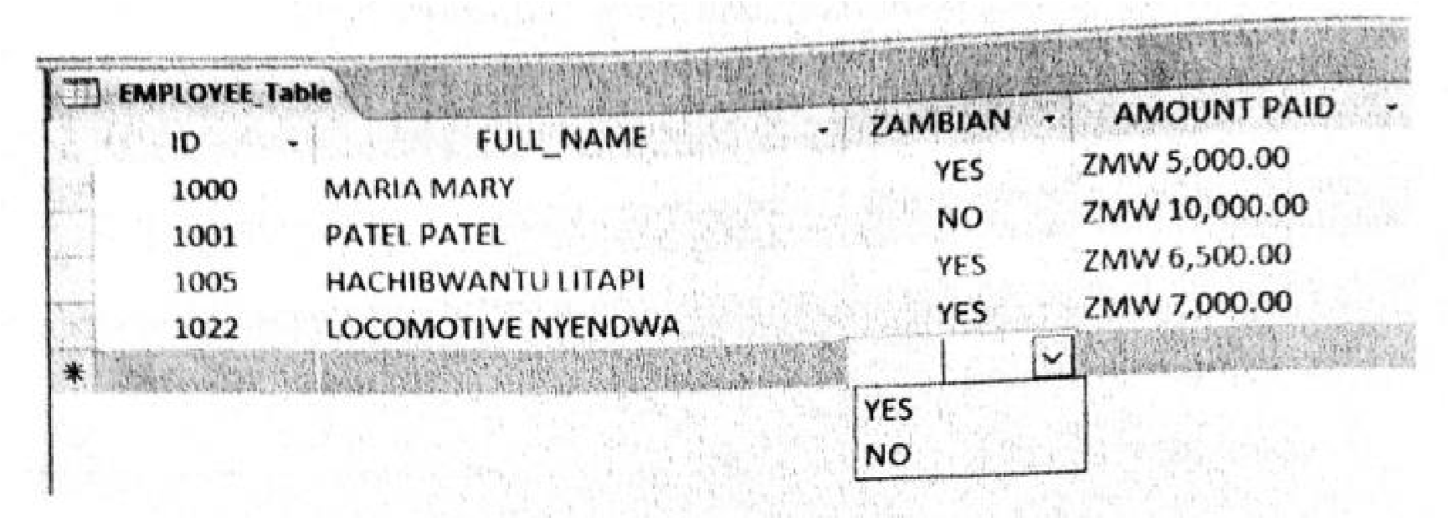

  - Complete the structure of the employee database using the following table.
Field | Data type | Field size
[4] (b) Identify the field that can be used as a primary key and give a reason. Primary Key:
Reason:

  - Give the output when the following SQL statement is executed:
SELECT * FROM employee_table WHERE AMOUNT_PAID < ZMW 6000.

  - Write the SQL statement to update the AMOUNT-PAID to ZMW 20 000 for ID
"1022."
- The following code is written in Pascal. Use it to answer the questions that follow. Program myprogram;
Var a:integer;
Begin
a = 50;
If (a <= 50) Do
Writeln('fail');
Else
Writeln('pass'); readln; End.

  - Identify the statement representing a variable, process and an output from the code. Variable
Process
Output

  - Convert the code into a flowchart.

  - State how to indicate a comment in Pascal.

  - Use number as variable to declare an array of ten integers.
[Total: 10 marks]

EXAMINATION COUNCIL OF ZAMBIA

Examination for General Certificate of Education Ordinary Level


Computer Studies 7010/1

Paper 1

Friday 26 JULY 2024

Additional information:

Time 2 hours 40 minutes Marks: 70
SECTION A: [50 MARKS]
Answer all questions in this section in the spaces provided.

1 (a) Explain the meaning of the term digitalisation.
- Give two methods of capturing data into a computer.
- Give one reason why a computer cannot process analogue data.
[Total: 5 marks] 2 (a) Give two examples of generic application software.
(b) Give two features that can be customised in generic application software.
[Total: 4 marks]

3 (a) Operating systems that have commands in form of pictures are common on many devices. Give the term used for these types of operating systems.
- State two tasks performed by an operating system.
- Give one operating system that uses text only for input of instructions.
[Total: 4 marks] 4 The following product table shows a record of items bought by a company. Use it to answer the questions that follow.
ID | Product Name | Description | Quantity | Purchase Date
A1 | Company chair | Green canvas | 20 | 2024-02-04
A2 | Table | Metal Square | 10 | 2022-01-01
A3 | Tent 1 | 2-man | 10 | 2004-02-20
A4 | Tent 2 | 6-man | 4 | 2004-07-20
A5 | Company chair | Blue canvas | 6 | 2022-08-17

- Name a field that can be used as a primary key.
- Give one advantage of splitting a database into many tables.
- Write a query to get a list of products purchased before 2023.

5 Explain the meaning of batch processing.
- State one application of batch processing.
- Give one drawback of batch processing.
[Total: 4 marks] 6 (a) Complete the following table for the given logic gates, NOT and NOR used in a logic circuit.
A | B | C | D = NOT B | E = C NOR D
0 | 0 | 0
1 | 0 | 1

(b) Give one application of logic gates.
[Total: 5 marks]

7 The following figure shows a robot fitted with sensors which is used to solder (fit) components on a computer circuit.
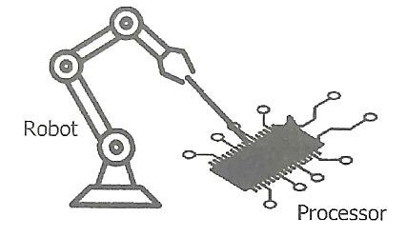
- Name one sensor that can be fitted in the robot.
- Give another task the robot can do on the computer circuit other than fitting components.
- Give one reason why robots are preferred to do such tasks rather than humans.
- State one feature of Computer Aid Design (CAD) software that can be installed in a robot.
[Total: 4 marks] 8 Four computers and a printer are connected to a central device to setup a network.
- Name the network topology created.
- State the name of a central device used on the network.
- Give one benefit of networking computers.
[Total: 3 marks] 9 The following diagram shows components of an expert system.
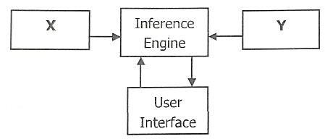
Name components X and Y.
- Give one application of expert systems.
- State one disadvantage of expert systems.
[Total: 4 marks] 10 Study the diagram of the network and answer the questions that follow.
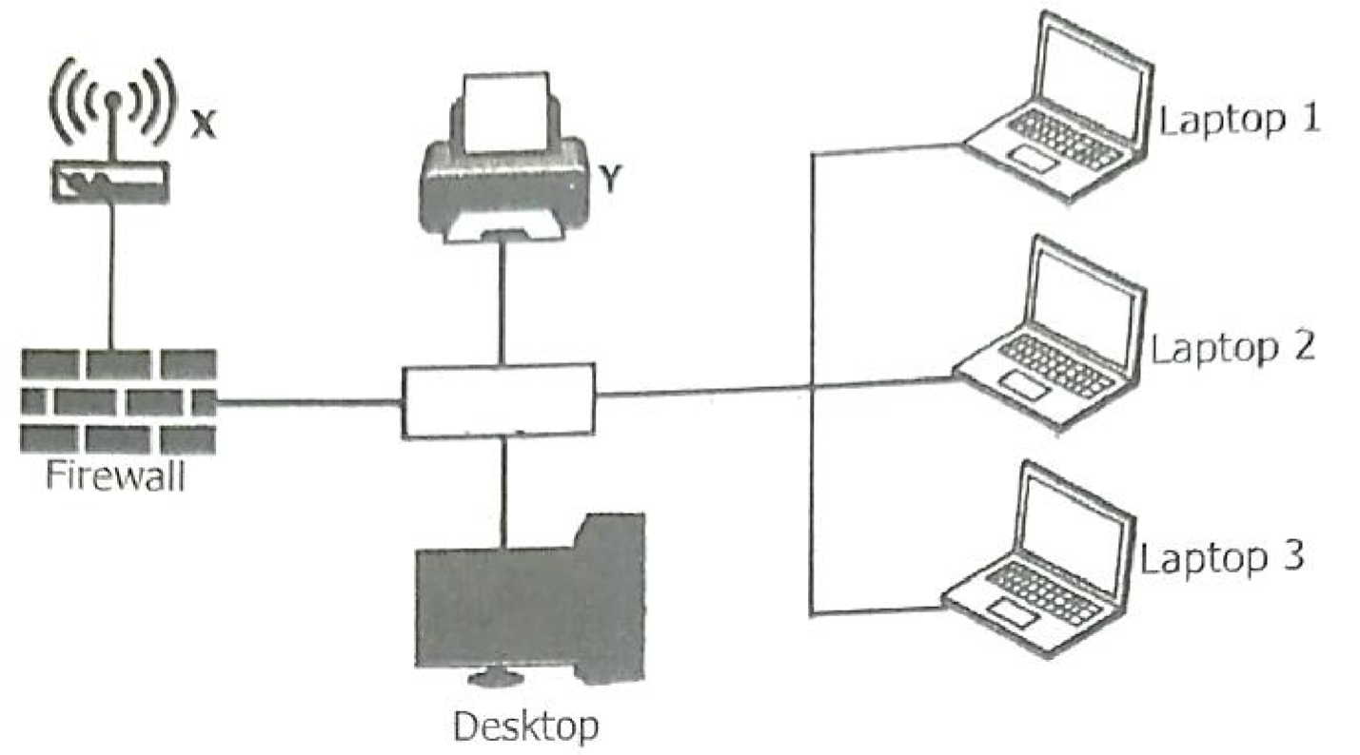

- Name devices X and Y.
- Give one other resource that can be shared on this network apart from devices X and Y.
- (i) State the purpose of the firewall on the network.
(ii) Give one disadvantage of the topology above.
[Total: 5 marks]

11 A company has offices in several countries and uses video conferencing and email to communicate.
- Give two benefits of using video conferencing.
- State one disadvantage of using video conferencing.
[Total: 3 marks] 12 Study the following algorithm.
Start
Enter title (e.g. Mr/Miss/Mrs)
IF title = "Mr" THEN
Gender = "Male"
ELSE IF title = "Miss" or title = "Mrs" THEN
Gender = "Female"
ELSE
Gender = "Gender undefined"
END IF
Stop

Write the output if the following titles were entered.
- Miss
- Professor

- Give a name of a statement that can be used in place of IF ... THEN ... ELSE.

- Name a control structure that uses the IF condition.
[Total: 4 marks]

SECTION B: [20 MARKS]
There are three (3) questions in this section. Answer two questions only. Question one (1) is Compulsory. Choose one from the other two questions.

- A systems analyst has been engaged to design and create a new database for a supermarket. The owner of the supermarket needs to know quickly when the stock is low so that more products could be ordered before they run out. Additionally, the owner needs to record each product uniquely and know the date (mm/dd/yyyy) each product was last ordered.

  - Complete the data dictionary table for the supermarket given below by providing a validation check which could be carried out on each field.
Field name | Validation check
Product ID
Barcode
Re_order_level
Last_ordered_date
[4]
  - Identify one type of test data and one example that can be used on last_ordered_date.
Type of test data ………………………………………………………………………………… [1]
Example of data ……………………………………………………………………………....... [1]

  - Give one advantage of each of the following methods of implementation.
Direct changeover for the supermarket……………………………………………………. [1]
Phased changeover for the supermarket. ………………………………………………… [1]

  - Describe two limitations of adopting the new computer based system when compared to the paper based system at the supermarket. [2]
[Total: 10 marks]

- Web pages are written with scripting languages and HTML.
  - Give one example of a scripting language. [1]

  - Explain the use of the named scripting language named in (a). [2]

  - Write the html code that links the cascading style sheet page called style.css to the main page. [2]

  - Write the html lines of code that will display the following:
DOGS
    - Wild dogs
    - Domestic dogs
    - Hyena
    - Wolf [3]

  - Write html code to display a background colour blue. [2]
[Total: 10 marks] 3 (a) State the purpose of the following in SQL.
    - Data manipulation language (DML). [1]
    - Data definition language (DDL). [1]

  - Explain the meaning of the term relational database. [2]

  - Write SQL command to:
    - Create a database called ECZ_DB_2024, [2]
    - Create a table called candidates with the following structure.
Name :- text
Salary :- currency [2]

(d) Write an SQL command to destroy the database structure created in part C (i).
[Total: 10 marks]

ANSWERS FOR GRADE 12 COMPUTER STUDIES – 2017 INTERNAL
SECTION A
- (a) Information

  - Give one advantage of soft copy easy to correct errors cheaper to store massive software easily updated

  - tablet smart phone

- (a) finger prints
Voice

  - Hardware is expensive
Privacy issues - people worry about privacy data stored especially finger print details

  - using a swipe card entering PIN

- (a) Relational database is database where data is held in two or more table which are linked with relationships OR
Relational database is a collection of records held in two or more tables which are linked by a relationship.

  - Device: Bar code reader Item: Books or membership card

  - sorting a database OR to search for a record

- (a) Octal is a base 8 number system whereas hexadecimal is a base 16 number system

  - 1100 (Octal): 1100_{Eight} = (1 x 8³) + (1 x 8²) + (0 x 8¹) + (0 x 8⁰)
= (1 x 8 x 8 x 8) + (1 x 8 x 8) + (0 x 8) + (0 x 1)
= 512 + 64 + 0 + 0
= 576_{ten}

IED (hexadecimal): IED _{sixteen} = (I x 16²) + (E x 16¹) + (D x 16⁰)
= (1 x 256) + (14 x 16) + (13 x 1)
= 256 + 224 + 13
= 493_{ten}

Therefore, 1100 (Octal) or 1100_{Eight} is greater than IED (hexadecimal) or IED _{sixteen}
- (a) A = Table frame and B = Chart or Graph frame

  - to import pictures/to insert pictures to insert video or multimedia clip to import video clip

  - beamer / projector / Screen / speaker

A | B | C | E = NOT C | F = A OR B | E AND F
1 | 0 | 1 | 0 | 1 | 0
1 | 1 | 0 | 1 | 1 | 1
  - document creation / inserting images and pictures / typing of text

6

- (a) User interface is a means of communication between the system and the user and between the system hardware and the software.

  - Dragging

  - Word Processor / Note Pad, Word Pad

  - Graphical user interface operating system

- (a) Data about humidity / Data about temperature

  - It automatically senses the change in the environment

  - To facilitate the continuous control without human intervention

- (a) Spreadsheet

  - Formula/ Function inserted automatically calculates total

  - Expand column width

  - Format currency/increase decimal

- (a) To find out if he would afford to carry out such a program
To find if the program will be available locally
To find out if he would be comfortable to use it

  - It is professionally done It is available and ready to use

  - Type 1: Normal Testing Type 2 Extreme Testing Abnormal Testing

- (a) Wide Area Network

  - Viruses / Hacking

  - A defect station does not affect the rest of the network
Simple to set up and configure
Requires less hardware and cabling than other network topologies
12
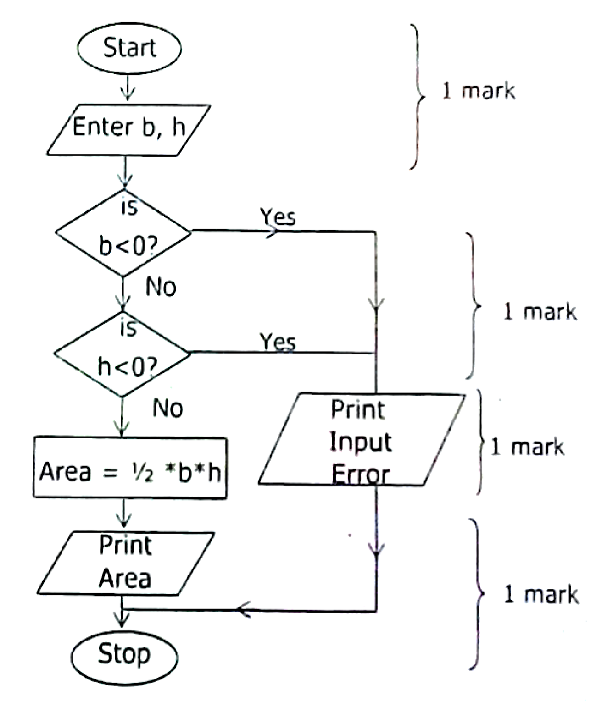

13 (a) Gantt chart
Pert chart
For scheduling times and duration of each activity in the project.

- Method: Questionnaires
Explanation: Users may not be willing to disclose information

- (i) To record details of a donation anywhere it is made
(ii) To allow for instant communication such as messaging when pupils are on the campaign to raise funds
- A Process symbol - to record calculations B Print out - receipts
C Storage -record of all details of the venture

- Field name1 Class Field name2 Date

- The Venture - Accuracy of records/update on the venture The Users - Users make less mistakes

- Corrective maintenance/adaptive maintenance programmed software

- System can be customized by custom or software instead of programmed software.
Can be posted online for anyone to donate from anywhere.

ANSWERS FOR GRADE 12 COMPUTER STUDIES PAPER 1 – 2019 INTERNAL Section A
- (a) Byte: is an 8 bits unit of data in a computer system.
  - Convert 4A to base ten
4A = (4 x 16¹) + (10 x 16⁰) = (4 x 16) + (10 x 1) = 64 + 10 = 74_{ten}
Convert 74_{ten} to base 2 (binary)
to base | quotient | Remainder
2 | 74
2 | 37 | 0
2 | 18 | 1
2 | 9 | 0
2 | 4 | 1
2 | 2 | 0
2 | 1 | 0
2 | 0 | 1

Therefore, 4A to binary = 01001010
- (a) INPUT: microphone for voice commands
OUTPUT: Speaker
  - Input: The microphone is used for various applications like adding sound to a multimedia presentation or for mixing music.
output: speaker it is responsible for producing sounds for people who cannot see.

- (a) Generic Software is a software that can perform many different tasks and it is not limited to one particular task.
  - (i) Microsoft word
    - Web browsers
  - Generic products are built by developers to be sold to a market of users, whereas custom products are commissioned by individual users with specific needs

- (a) (i) Batch Operating System.
(ii) Multitasking/Time Sharing OS
  - (i) antivirus software
    - backup software

- (i) Putting liquid and food substance near the computer. Antivirus software, backup software
(ii) Don’t switch off the computer using power button rather user the shutdown command feature.

- (a) Hardware: is physical part/component of a computer system
  - Threat 1: dust
Threat 2: Liquids

- (a) M = NOT gate
N = NAND gate
  - (i) alarms
    - computer decoder

- (a) X = user Interface W = database
  - Database/knowledge base
  - it is difficult to keep updates of the knowledge base and the database.

- (a) Iterm code

  - (i) to organise the records in a specific location (ii) to uniquely identify the location.

- (a) Bus Topology network
  - (i) It is very easy to implement .
    - The fault of the Network cable results into the failure of the all system.

- (a) (i) Brightness or the light intensity of the monitor
(ii) cyber threats such as hacking, cracking or intrusions

- (a) 15
  - ………………..

- (a) (i) it had too much paper work(redundancy)
(ii) its had to retrieve data and they could be natural disaster such as fire or theft.

  - (i) To store all the records and retrieve when needed.
    - To determine how best records can be processed and validated

ANSWERS FOR GRADE 12 COMPUTER STUDIES PAPER 1 – 2021 INTERNAL

SECTION A

- Windows Buttons Dialogue boxes
Pointers Icons Pop ups
News

- (a) Natural Science / C

(b) (i) Natural Science Department
(ii) Test 1 and Test 2

(c) By restoring them from the recycle bin.

- (a) Hard copy

(b) (i) dot matrix / daisy wheel / line printers / thermal printer
(ii) LaserJet / Inkjet Printer

(c) Robust able to work in a dirty and dump environment
Prints on multi art paper
Slow and noise

- (a) 8E: (E = 15) (8 x 16¹) + (15 x 16⁰) = 128 + 15 = 143_{ten}

(b) To save space Quick validation Quick entry Quick search

- (a) A record is a collection of fields about one item or information about a person while a file is an organised collection of records.

    - Alphanumeric Numeric Decimal Integer
Date/time Currency
Boolean Short text

    - Foreign Key / Secondary key

- (a) Tutorials Online examination
Drilling e – library / online library

    - Dependance on power supply
No social interaction
Consultation is limited
Learner may feel isolated from the instructor.

    - Cyber bullying
Disermination / publication of unverified news
Lack of concentration on school work

- (a) Presentation software

(b) Piracy

- (a) Not to open emails from unknown people
Never to give personal information unless after confirmation with source mentioned.
Installing anti-spy software/antivirus

      - Keeping logs of visited sites
Keeping logs of user preferences (e.g. buying preferences) Remember the user each time they log onto the website.

      - Spam

A | B | C | S | T | X
1 | 1 | 1 | 0 | 1 | 1
1 | 1 | 0 | 0 | 0 | 0
1 | 0 | 1 | 0 | 0 | 0
1 | 0 | 0 | 0 | 0 | 0
0 | 1 | 1 | 1 | 1 | 1
0 | 1 | 0 | 0 | 0 | 0
0 | 0 | 1 | 1 | 0 | 1
0 | 0 | 0 | 1 | 0 | 1
      - Modified / Deleted

9

  - (a) Communication
Searching
Sharing

(b) PART A Protocol PART B Server / domain
PART C File / document

  - (a) 8 rows

      - C3 / C2

      - Easier to explain/ change data/ variables.
Cost less to change data/ variables.
The real thing may be impossible to create.
You can test predictions more easily/ model can make predictions more accurately.
You can ask many WHAT IF questions which would be impractical in real life. Results are obtained more quickly.

12 (a) File M = Old master file

- K = Sorting
L = Validation

- Checking for correctness on entered data.
Ensuring that correct sorting was carried out.
Checking for errors in the transaction file.

SECTION B
- (a) Not easy to update
Difficult to secure records
Task | Stage
Observe the current system in operation | Analysis
Software and hardware installation | Implementation
Prepare data capture and validation methods | Design
Decide whether or not to continue with the project | Feasibility study
Takes time to search for a specific record

(b)

  - Meets user's needs Easier to modify

  - Normal / Abnormal / Extreme

  - How to start/ load the program How to Log in/ Log off

  - Any appropriate explanation Fix errors / bugs
Perfective maintenance

- (a) Relative hyper links
Obsolute hyper links
Reference hyper links
Email hyper links

  - < a href = "Contact us.html> contact us </a>

  - < font colour = "Red"> my school </font>

 | (d) | < ol> subjects
< li > Mathematics
<li> Science
< li> English
<li> Computer Studies
< /ol >
3 | (a) | SELECT  INSERT  ALTER  CREATE  UPDATE  DELETE
 | (b) | (i) Name field: Char / varchar
 |  | Salary field: number

    - SELECT*
FROM employee
ORDERED BY Name, salary

    - DELETE FROM employee WHERE employee No. = M1104

ANSWERS FOR GRADE 12 COMPUTER STUDIES PAPER 1 – 2022 G.C.E

1 (a) Input device is any device used to enter data into a computer e.g keyboard / mouse.

(b) software: speech synthesis / voice recognition / speech to text
Hardware: microphone
2
S/N | Job title | Duties
1 | Web developer / web designer | Designs and develops websites
2 | Computer Technician | Repair / maintenance of hardware and software trouble shootings
3 | Database Administrator | Create and maintain databases
4 | End user support or Support staff | Offers support to staff when problems arise as they are technical support

- (a) Barcode scanner / MICR / OCR

  - Range cheek

  - To ensure that data entered on the system is the same as the data on the source document or on disk.
To ensure that data entered first is the same as data entered second.

- (a) OR gate

  - (i)

NAND gate

    - (1 x 2³) + (1 x 2²) + (1 x 2¹) + (0 x 2⁰) = 8 + 4 + 2 + 0 = 14_{ten}

- (a) (i) Safe as there is no need of carrying cash
More portable than cash

(ii) more portable than cash
Safe as there is no need to carry cash
Less risking from robs
More security than cash

  - cash not readily available to bring goods where EFPOS is not applicable.
Increased levels of fraud (cybercrimes)

- (a) Ethernet cable / backbone / Bus

  - (i) Q: It absorbs data signals
    - It provides location for shared disk access or to store files and applications.

  - Modern / Reuter / Brouter

- (a) 1 Access to free updates
2 free online consultation / support

  - 1 Flood
2 Fire / Earthquakes

- (a) C2*D2 or PRODUCT (C2, D2)

  - IF (B2 < = 10, ‘’Re – Order’’, ‘’Stock level OK’’) or
IF (B2 > 10, ‘’Stock level OK’’ ‘’Re – Order’’,)

    - Data: A1 : D5 or E1 : F1
    - Information: F2 : F5
- (a)
A | N | OUTPUT
2  6  18 | 50  40  30  20 | 18, 20

  - WHILE DO

- (a) Automatic gathering / sampling of data using sensors.

  - More accurate than manual entry
No errors
Work 24/7

  - Charts / Graphics / cables

- (a) Text / videos / Audios / animations / picture (image / photographs)

  - speaker / microphone / projector

  - Improve problem solving
Deeper understandings
Increase positive emotions
Word exploration

- (a) 10 9 8 7 6 5 4 3 2 1 5 1 0 4 3 2 2 0 1 7

Step 1: (1 + 4 + 2 + 0 + 7) x 3 = 14 x 3 = 42
Step 2: 5 + 0 + 3 + 2 + 1 = 11
Step 3: 42 + 11 = 53
Step 4: The next multiple of 10 is 60
Step 5: 60 – 53 = 7, Thus 7 is the cheek digit

SECTION B [20 MARKS]

- (a) Computer objectives: Easy update
To search the database
Quick entry
Business objectives: Fast executions of transactions

  - Method 1: Parallel change over
Advantage: can easily insert to old if new fails

Method 2: Pilot change over
Advantage: System can thoroughly be tested without any risk

  - 1 If one office loss information, not all information about the learner is lost.
(Natural backup of learner’s information)
- It is cross reference information

(d) 1 Normal data
- Abnormal data
- Extreme data

- (a) Line 2: int main ( )
Line 4: C int
Line 6: a

  - 1 A variable cannot start with a number.
    - There can never be space in variables.
    - A variable can start with an underscore ( - )

(c) 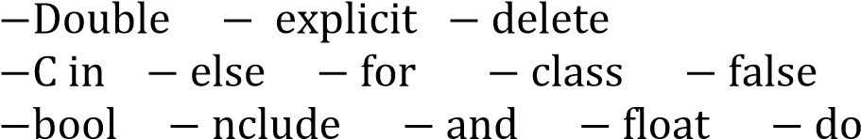

  - { : Begin
Cout: output / print / display

  - compiler / IED

- (a) (i) SELECT * FROM student;
    - SELECT * FROM Student ORDER By STNO ASC:
    - INSERT INTO STUDENT VALUES (1010, ‘’Bwalya. T’’, 12B ‘’additional mathematics’’)

  - SLNo

  - Text / varchar / string

  - Query

  - 4

ANSWERS FOR GRADE 12 COMPUTER STUDIES PAPER 1 – 2022 INTERNAL

- (a) Printer
Plotter
Fax machine

  - Similarities: Both contain data that can be read Both are on the motherboard
Both are used for memory/storage

Difference: RAM volatile ROM is not
RAM be read and written to, ROM can only be read from

  - Identify New viruses

- (a) 0100

  - 12₈

  - That is the language the computer understands

- (a) It is the replacement of human skill with computer-based system

  - Work 24/7
Faster job execution
More accurate than manual

  - Learning through imitation
By artificial intelligence ability to make program
Learning through rehearsals under program control

- (a) (i) Public: Name
Address
Gender
(ii) Private: Political affiliation
Medical health records
Liabilities accrued
  - Data must be accurate
Data must not be kept longer than necessary Data must adequate

  - Loss of business
Loss of confidence in the company by customers Loss of privacy

- (a) (i) Local Disk (C:)

(ii) Local Text Files Program Files
WINDOWS

  - Security
Loading of program
Disk management

- (a) Intranets is accessible only within an organisation whereas extranet is accessible by outsiders with limited privileges.

  - By encrypting of some information
Access control

- Repeat [Forward 30º left 120º] three times or Repeat 3 [Forward 30º left 120º]

- (a) Oxygen Sensor
Carbon dioxide Sensor

  - Analog -to - digital converter or ADC

  - Monitor – Observes the physical variable without the microprocessor taking action whereas in control systems, the microprocessor takes an action depending on sensor reading.

- (a) It is computer system that captures and recognizes a person's unique physical characteristic for personal identification

  - Finger print scanner / Eye scanner

  - More secure / uniquely password / It identify the user

- (a) 5

  - Format check Presence check
Length check
(c)
Field  Table  Sort  Show  Criteria or | Show Number |  |  | Type |  |  | Title |  |  | Date |  |  | Sold out
Field  Table  Sort  Show  Criteria or | Performance |  |  | Perform |  | ance | Perform |  | ance | Perform |  | ance | Performance
Field  Table  Sort  Show  Criteria or |  |  |  |  |  |  |  |  |  | Ascendi |  | ng
Field  Table  Sort  Show  Criteria or |  |  |  |  | 
Field  Table  Sort  Show  Criteria or |  |  |  |  |  |  |  |  |  |  |  |  | ‘’YES’’

- (a)
x | m | y | z
4 | 1 | 3 | 14
4 | 2 | 2 | 8
4 | 3 | 1 | 2
4 | 4 | 0 | - 4

  - While... do
Repeat... until

- (a) Digital crime is the using of computer or other electronic devices to steal money, destroy data, maliciously attack users

  - People become reluctant to use online transactions Reduce business on mobile money
People lose confidence in ICTs for doing business
People are reluctant to use mobile money

  - Strict punishment on offender
Sensitization
Tightening security policies on network
Using strong passwords

SECTION B: (20 MARKS]
- (a) GANTT Chart Spreadsheet PERT chart

  - Interview - allows full and frank answers
Questionnaire -Cheap way to obtain information from a large number of people
Observation - possible to see exactly what is done
- can gain information not obtained by other methods

  - To ensure that the minimum requirements are met To ensure that the system is compatible

  - Because it has a fall back system/A backup system in case new system fails

- (a) Integer is numeric whereas string is a combination of characters (text and or numeric)

  - Average of n1 and n2 is 5: Line 11 / Error
My name is, Sepo: Line 12 / Error
Nothing: Line 13 / Error

  - n1, n2, real

  - Extensive library Modules are easily used Uses subroutine Use subprograms and functions

  - END

- (a) (i) <table border = 1>
<tr> <td> Name </td>
<td> ID </td> </tr>
<tr> <td> </td>
<td> </td>
</tr>

(ii) <li> Red</li> <li>Blue</li>
</Vl>

  - <br/>
<hr/>
<ling src = ‘’’’/>

  - It describes the look and formatting of a document written in mark up language.

ANSWERS FOR GRADE 12 COMPUTER STUDIES PAPER 1 – 2023 G.C.E
SECTION A: [50 MARKS]
- (a) any one: CD / DVD/ Flash / memory card / external hard disk

    - Any one: Projector / speaker / LEDs / Earphone / Headsets / printer

    - Quick entry
Reduced human error
Weather resistant
- Any three: Security / Interrupt handling / Multiprocess / Spooling / User interface Input/output control / File management

- (i) F A 7
1111 1010 0111
111110100111

(i) 7647

- (a) Any two: Installation of fire detector. Fire proof ceiling/safes. Offsite backups
e.g. cloud computing. Automatic fire extinguisher.

(b) Running offsite backup. Use of backup. Retrieve from the cloud. Using file generations

- (a) Any one: More portable than carrying money. Secure. Offers 24 hours banking
Service.

    - Offers extra service without incurring additional costs.

    - (i) Presence check / check digit
(ii) Type check / Length check

- (a) Any two: Reskilling/Redundancy/Job loss. Reskilling/Re-training Telecommuting/e-working

(b) Any two: RSI. Headaches. Necklaces. Eye strain. Backaches

- (a) A star topology network which has a server and a printer.
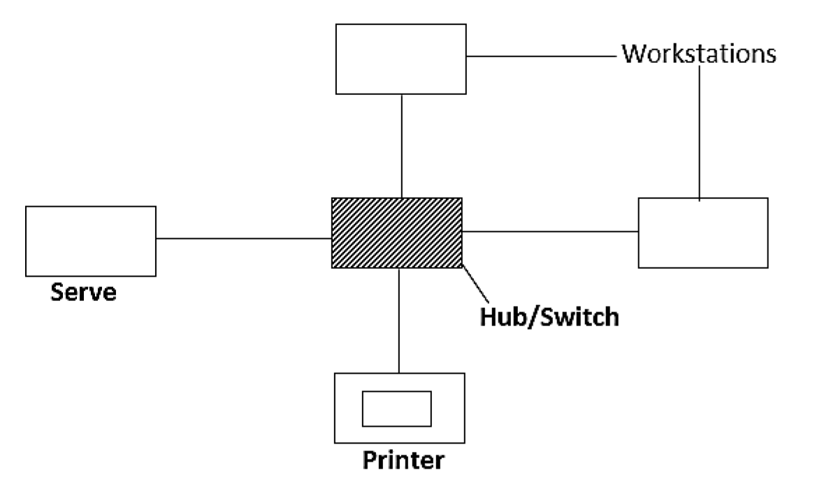

(b) Extranet is an extension of the intranet while Intranet is more secure than extranet Intranet is limited to men bus of the organisation while extranet gives partial access to the public.
Extranet facilitates controlled communication to clients, parties and suppliers while intranet facilitates internal communication of the resource.

- (a) = D2*C2
= Product (C2, D2)

(b) Any three: E3, E4, E5, E6

- (a) It is a computer program used to produce technical drawings.

    - Any two: Aerospace. Road construction by architects/engineers
Arrangement of furniture in a room
    - Any one: Library of parts. 2D to 3D. Links to CAM. Kinematics

- Right 90º.
Forward 5. Right 135º.
Forward 3.5

- (a) 1111011

    - 7
    - Limited number of bits
12
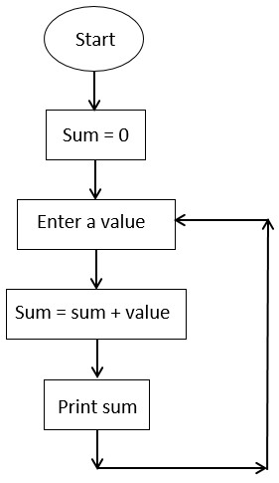

SECTION B: [20 MARKS]
- (a) (i) Analysis/Feasibility stage
(ii) Design stage
(b)
Situation | Change-over method | Reason
Point of Sale (POS) for a supermarket | Phased | Low Cost of implementation
Medical System | Parallel or phase | Ample time to learn new system.  Minimise the negative impact in case of failure
Newly completed video library | Pilot / Direct | Low cost of implementation

(c) (i) Gantt chart (ii) Task A
Task B
(iii) Task C

- (a) CREATE TABLE Student (
Student voucher / text (6)
Fullname voucher / text (14)
Subject voucher / text (7)
Mark int/ numeric
PRIMARY KEY (StudentNo),
);
  - SELECT full name, subject FROM student WHERE Mark > 75;

  - INSERT INTO Student (StudentNo, fullname, subject, mark) Values (ST1410’, ‘Juliet Bwalya’, 'English', 95)

- (a) Any two: number. Count. answer

  - Enter a number

  - (i) 4
(ii) 1

  - 4
8
12
16

  - Any one: repeat, if, uses, Crt, until, while, eof,

ANSWERS FOR GRADE 12 COMPUTER STUDIES – 2023 INTERNAL
- (a) Data: Raw, unprocessed facts and figures (e.g., numbers, text).
Information: Processed, organized, or structured data that is meaningful (e.g., a report generated from data).
  - Device to capture analogue data at a point-of-sale: Barcode scanner.
  - Smallest data size that can be stored in a computer system: A bit (binary digit).

- (a) Data bus: Transfers actual data between the processor, memory, and other components.
Address bus: Carries the addresses of data (not the data itself) to be read or written.
  - The program counter keeps track of the next instruction to be executed in the sequence by storing its memory address.

- (a) Customization to meet specific business needs.
Competitive advantage by supporting unique business processes.
  - (i) Example: Linux.
    - Advantage: Freedom to modify and distribute the software according to specific needs.

- (a) (i) L: NOT gate (inverter).
(ii) Purpose of logic gate M: The logic gate M might be an AND gate, and it processes the inputs to produce an output only when all conditions (inputs) are true.
  - Truth table for NAND gate:
A | B | OUTPUT
0 | 0 | 1
0 | 1 | 1
1 | 0 | 1
1 | 1 | 0

- (a) Easier distribution and access; users can download and read books anytime, anywhere. (b) Scanner.
  - Managing the digital catalog and ensuring that digital resources are accessible to users.
  - Requires internet access or a digital device to access resources, which may not be available to all users.

- (a) Position: Cybersecurity Analyst
Responsibility: Monitors and tracks criminal activities such as fraud and hacking.

  - To protect the company’s network from security risks, such as malware, that could be introduced by personal devices.

  - (i) Use of X: Likely used to sum up the salaries of all employees, indicated by the cell D8, which shows the total salary.
    - Text formatting or alignment (e.g., bold or center alignment).
    - Function in D8 for Walubita’s salary: =C3*D3 or simply =B2*C2.

- (a) Modem or Network Interface Card (NIC).
  - Email services or web hosting.
  - Encryption.
  - Domain Name System (DNS).

- (a) String (e.g., "Hello, World!")
Integer (e.g., 42)
  - Meaning of 'debugging': The process of identifying, analyzing, and removing errors or bugs from software.

- (a) Proximity sensor (to detect obstacles or the presence of crops). (b) Disadvantage: High initial cost and maintenance expenses.
  - Activity: Drawing a path or pattern to follow for planting seeds.
  - A robot can be updated with new algorithms or instructions via software updates to perform new tasks.

- (a) (i) Project Planning: Time management.
(ii) Project Monitoring: Analytical skills.
  - Gantt chart.
PERT (Program Evaluation and Review Technique) chart.

- Pseudocode for the flowchart:
Start
If symptoms then
Quarantine
Start treatment
Else
Do other tests
End if
Stop

SECTION B

- (a) Computer objective: Automate stock tracking and reorder processes. Business objective: Reduce stock shortages and overstock, thus improving efficiency.

  - Source 1: Interviews with staff.
Source 2: Review of existing documents and reports.
  - To gain management approval and support for the new system.

  - 1 Conduct cost-benefit analysis.
- Assess technical and operational feasibility.

- To provide quick answers to common questions, improving user experience and reducing support requests.

- Adaptive maintenance.

- (a) Completed structure of the employee database
Field | Data type | Field size
Employee ID | Integer | 4 bytes
Name | VARCHAR | 100
Amount paid | DECIMAL (10.2) | 8 bytes

  - Primary key: Employee ID.
Reason: Uniquely identifies each employee in the table.

  - It will display all employee records where AMOUNT_PAID is less than ZMW 6000.

  - UPDATE employee table SET AMOUNT_PAID = 2000 WHERE Employee ID = 1022:

- (a) Variable: ‘a: integer;’
Process: ‘If (a = 50) Do’
Output: ‘Write In(‘fail’);’

  - Start → Initialize a → If a ≤ 50 then → Print "fail" → Else → Print "pass" → Stop.

  - Indicating a comment in Pascal: Use {} or (* *) to enclose comments.

  - var number: array [1..10] of integer;

ANSWERS FOR GRADE 12 COMPUTER STUDIES – 2024 G.C.E
SECTION A: [50 MARKS]
- (a) - Change of a system to be operated using a computer and internet.
- Change of a physical, hardcopy documents, process to a digital or computerised or to be using computers

  - - Direct entry - using automated input devices e.g. sensors, OMR, OCR - Manual entry - using keyboard and mouse / data entry

  - - Computers only read, understand digital data/signals
    - Computers interpret continuously varying data

- (a) - Adobe suite/Microsoft office/Open office/Apple works
- Word processor/Excel/Spreadsheet/Database/Powerpoint/Publisher

  - - Macros, - Printing feature, - Insert feature, - Formatting feature, - Hyperlink feature, - Edit feature

- (a) Graphical User Interface/GUI

  - Loading of programs/memory management/security management/file management/peripheral management

  - Unix/Linux/ /MaCOS termmal/ Free BSD/DOS

- (a) ID

  - Data security is improved/Data consistence/No duplication of data - reduce data redundancy

  - SELECT * FROM product WHERE Purchase-date<’’2023”

- (a) Collection of data over a period of time and processed at once.

  - - Processing of utility bills/bank cheques
    - Invoices, receipts, payslips

  - - Once the process starts, no intervention/outdated data
    - Process is sometimes too slow

- (a)
A | B | C | D = NOT B | E = C NOR D
0 | 0 | 0 | 1 | 0
1 | 0 | 1 | 1 | 0
  - - Electronic circuits, - Switches, - Electronic gates, - Electricity circuits - Alarm systems, - Electronic bells

- (a) Proximity sensor/ /Distance sensor

  - Removing faulty components/Detecting faulty components/ blows of dust

  - - Accuracy/Speed/Consistency

  - 2D to 3D/modelling/simulation/costing/library of parts

- (a) Star topology

  - Hub/switch

  - Facilitate communication/sharing hardware resources/sharing software resources/internet

- (a) X is knowledge base /role base
Y is rule base/ Knowledge base

  - Chess game/mineral prospecting/rock identification/medical diagnosis

  - Expensive to buy/lack common sense

- (a) X - router
Y - Printer

  - - Database and Internet / fax / scanner

  - (i) Block Viruses / hackers
      - Blocking data from blocked site from entering the network
      - Monitoring incoming messages and filter then
(ii) - Hacking by employees, - Sabotage by employees, - Data theft by employees

- (a) - Collaboration with team without having to leave your desk
    - More realistic meeting because of visual and audio contacts
    - No travel costs
    - Meeting can be set up at short notice

  - - Network connectivity can be difficult/challenges on connectivity
    - Hardware may be expensive to buy
    - Connection cost or data costs may be high

- (a) (i) Female
(ii) Gender undefined

  - Case/Case of

  - Branch

SECTION B: [20 MARKS]
- (a) Product ID: Format check/presence check/character check

Barcode: Check digit/format check/presence check/length check

Re order level: Presence check/charcter check/length check

Last ordered date: Presence check/format check/type check

  - Normal data: Data not in future or now/moment and must follow the format given
Example: Accept any date before 26/07/2024

  - Direct changeover, - Quicker implementation,
      - Benefits of the new system are immediate
Phased changeover - If the latest part fails, failure is not disastrous
      - Its possible to ensure that the system works before expanding

  - - Needs electricity to work, - Requires trained personnel

- (a) - CSS (Cascadingg style sheets)
    - php (hypertext pre-processor)
    - Javascript

  - CSS - define page layout e
Php - make page dynamic, allows communication with database and page

  - <link ref = "stylesheet" type = "text/CSS" href = "style.CSS">

  - DOGS
<ol>
<li>wild dogs</li>
<li>Domestic dogs<li>
<li>Hyena</li>
<li> wolf </li>
</ol>

(d) <body bgcolor= "blue"> </body>

- (a) DDL
To define the structure of objects such as database, tables, etc

DML
To manipulate data e.g. insert, delete, update, etc

- A database made up several tables that are linked together.

- (i) CREATE database ECZ_DB_2024

(ii) Create table candidates
Name : text
Salary : currency

- DROP database ECZ_DB_2024

